

***Operating Lease Support System Phase-2 Project***

***for***

****

***Functional Specification***

***FC.AB.1.1 Manage Visit Customer Survey Report***

Revision 0.5

**PT. Berlian Sistem Informasi**

KTB Annex Bld. 4th Floor, Jl. Jend. A. Yani. Pulomas,

Tel. +62 21 4786 7575 (Hunting) Fax. +62 21 4714964 www.bsi.co.id

Document Control

|  |  |
| --- | --- |
| **Author** | Raymond |
| **File Name** |  |
| **Path** |  |
| **Number of Page** |  |

Revision History

|  |  |  |  |
| --- | --- | --- | --- |
| **Date** | **Revision** | **Description** | **Author** |
| 1/10/2015 | 0.0 | Initialization | Raymond |
| 22/10/2015 | 0.1 | * Adding Functional Specification for List of Visit Customer Survey * Adding Functional Specification for Create Visit Customer Survey * Adding Functional Specification for Edit Visit Customer Survey * Adding Functional Specification for View Visit Customer Survey * Adding Functional Specification for Print Visit Customer Survey | Raymond |
| 22/10/2015 | 0.2 | * Revise and add some missed contents | Raymond |
| 30/10/2015 | 0.3 | * Adding screen design for all Functions | Raymond |
| 19/11/2015 | 0.4 | * QCO Review * Update Review QCO | Raymond |
| 30/12/2015 | 0.5 | * Revise and add some missed contents | Raymond |

Distribution List

|  |  |  |
| --- | --- | --- |
| Name | Organization | Roles |
| Mr. Jin Nishimura | Dipo Star Finance, PT | DSF Project Director |
| Mr. Shinji Hosokawa | Dipo Star Finance, PT | DSF Project Advisor |
| Mr. Ahmad Fikri | Dipo Star Finance, PT | DSF Project Advisor |
| Mr. Abdul Somad | Dipo Star Finance, PT | DSF Project Manager |
| Mr. Delta Riangga | Dipo Star Finance, PT | DSF Key User |
| Mr. Mochamad Idris | Dipo Star Finance, PT | DSF Key User |
| Mrs. Herni Hembang | Dipo Star Finance, PT | DSF Key User |
| Mr. Junaidi Didy | Dipo Star Finance, PT | DSF Key User |
| Mr. Dedi Supriyadi | Dipo Star Finance,PT | DSF Key User |
| Mrs. Elke Hilviana | Dipo Star Finance,PT | DSF Key User |
| Mr. Mukhlis Ibrahim | Dipo Star Finance, PT | DSF IT Department Representative |
| Mr. Roby Wijaya | Dipo Star Finance, PT | DSF IT Department Representative |
| Mr. Daiki Kamada | Berlian Sistem Informasi, PT | BSI Project Director |
| Mr. Feri Irawan | Berlian Sistem Informasi, PT | BSI Project Advisor |
| Mr. Grand Zah Putra | Berlian Sistem Informasi, PT | BSI Project Manager |
| Mr. Raymond | Berlian Sistem Informasi, PT | BSI Business Analyst |

Document Approval

By signing this document I acknowledge I have read the document and give the Project Management Team approval to proceed.

|  |  |  |  |
| --- | --- | --- | --- |
| Role | Name | Signature | Date |
| DSF Project Director | Mr. Jin Nishimura |  |  |
| DSF Project Advisor | Mr. Ahmad Fikri |  |  |
| DSF Project Manager | Mr. Abdul Somad |  |  |
| DSF IT Department Representative | Mr. Mukhlis Ibrahim |  |  |
| BSI Project Director | Mr. Daiki Kamada |  |  |
| BSI Project Advisor | Mr. Feri Irawan |  |  |
| BSI Project Manager | Mr. Grand Zah Putra |  |  |
| BSI Business Analyst | Mr. Raymond |  |  |

Table of Contents

Document Control 2

Revision History 2

Distribution List 3

Document Approval 4

1. Introduction 6

1.1 Purpose 6

1.2 Scope 6

1.3 Definition, Acronyms, and Abbreviations 6

2.4 References 6

2. Configuration 7

3. Detail Specification: FC.AB.1.1 Manage Visit Customer Survey Report 7

3.1. Purpose 7

3.2. Screen of Configuration Access 7

3.3. Screen Functionality 7

3.4. Operation Flow 8

3.5. Screen Design 8

3.6. Component Screen Functionality 13

3.7. Operation Description 22

3.8. Screen Item List 38

3.9. Data Structure 46

1. Introduction
   1. Purpose

Functional Specification is a document to describe the detail of functions system which includes screen design, report, and logic formula. This document will be used for system development.

* 1. Scope

Functional Specification Document contains screen design, screen functionality, process flow, and data structure of FC.AB.1.1 Visit Customer Survey for Phase-2

Here are the scope for FC.AB.1.1 Visit Customer Survey

1. **AB.1.3.1 Create Customer Survey Report**

To create Visit Customer Survey report inputted from a survey result

1. **AB.1.3.2 Edit Customer Survey Report**

To edit a draft document of Visit Customer Survey

1. **AB.1.3.3 Submit Customer Survey Report**

To submit Visit Customer Survey Report and send email to DSF Authorized Person

Output from this document is:

1. PF.AB.1.1 Visit Customer Survey Form
2. RPT.AB.1.1 Visit Customer Survey Report
   1. Definition, Acronyms, and Abbreviations
3. OPL = Operating Lease
4. DSF = Dipo Star Finance
5. BSI = Berlian Sistem Informasi
6. HOB = Head of Branch
7. HOD = Head of Department
8. RM = Regional Manager
9. SKD = Surat Keputusan Direksi/ Board of Director’s Decree
   1. References

This functional specification document refers to **“To Be Design” AB. Marketing Process**, module:

1. AB.1 Bidding of Operating Lease

* AB.1.3 Customer Survey Report Creation

1. Configuration

* N/A

1. Detail Specification: FC.AB.1.1 Manage Visit Customer Survey Report
   1. Purpose

The screens used in Manage Visit Customer Survey Report are used to Create, Edit, and Submit the Visit Customer Survey and generate an output as a print form of the Visit Customer Survey and also an email delivered to DSF Authorized Person.

* 1. Screen of Configuration Access

Here are the access right for users:

|  |  |  |  |  |
| --- | --- | --- | --- | --- |
| ***User*** | ***Create*** | ***Read*** | ***Update*** | **Authorization** |
| Marketing Officer | v | v | v | - |
| Head of Branch | - | v | - | - |
| Head of Department | - | v | - | - |
| Regional Manager | - | v | - | - |
| Advisor | - | v | - | - |
| Director | - | v | - | - |
| President Director | - | v | - | - |
| Shareholder’s Meeting | - | v | - | - |

* 1. Screen Functionality

1. Show lists of Visit Customer Survey record data
2. Create a Visit Customer Survey
3. Edit a draft document of Visit Customer Survey
4. View a Visit Customer Survey
5. Submit a Visit Customer Survey
6. Print a Visit Customer Survey
   1. Operation Flow

Below is operation flow for Monitoring and print unit preparation process refer to **To Be Design Document Marketing Process**, **AB.1.3 Customer Survey Report**:

|  |  |
| --- | --- |
| **PIC PC** | **Process** |
|  | Master Data Customer  (Customer)  D:\Users\bsi00815\Desktop\PrintScreen\SKD\Customer Visit Survey\Customer Visit Survey v2\VCS_Create.png  Master Data Product  (Product)    Visit Customer Survey  (Tb\_MKT\_VisitCustSurvey)  Note:  Source  Output & Input |

* 1. Screen Design
* *Initial Screen Manage Visit Customer Survey*

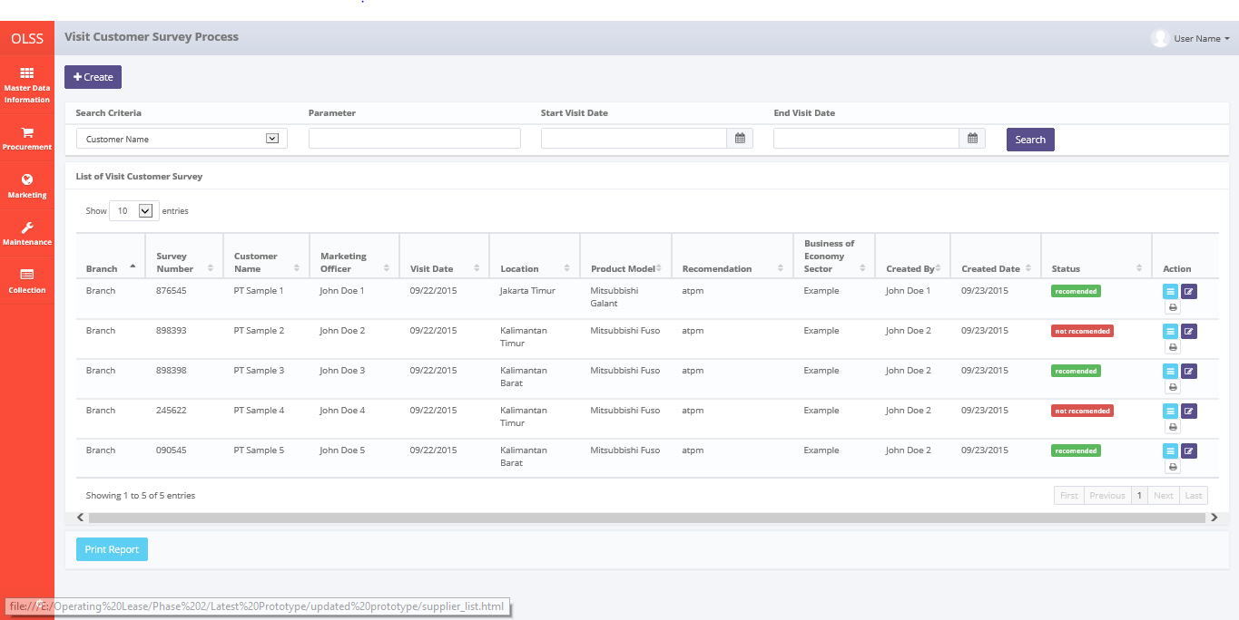

*Screen 1. List of Visit Customer Survey*

* *Create Visit Customer Survey*

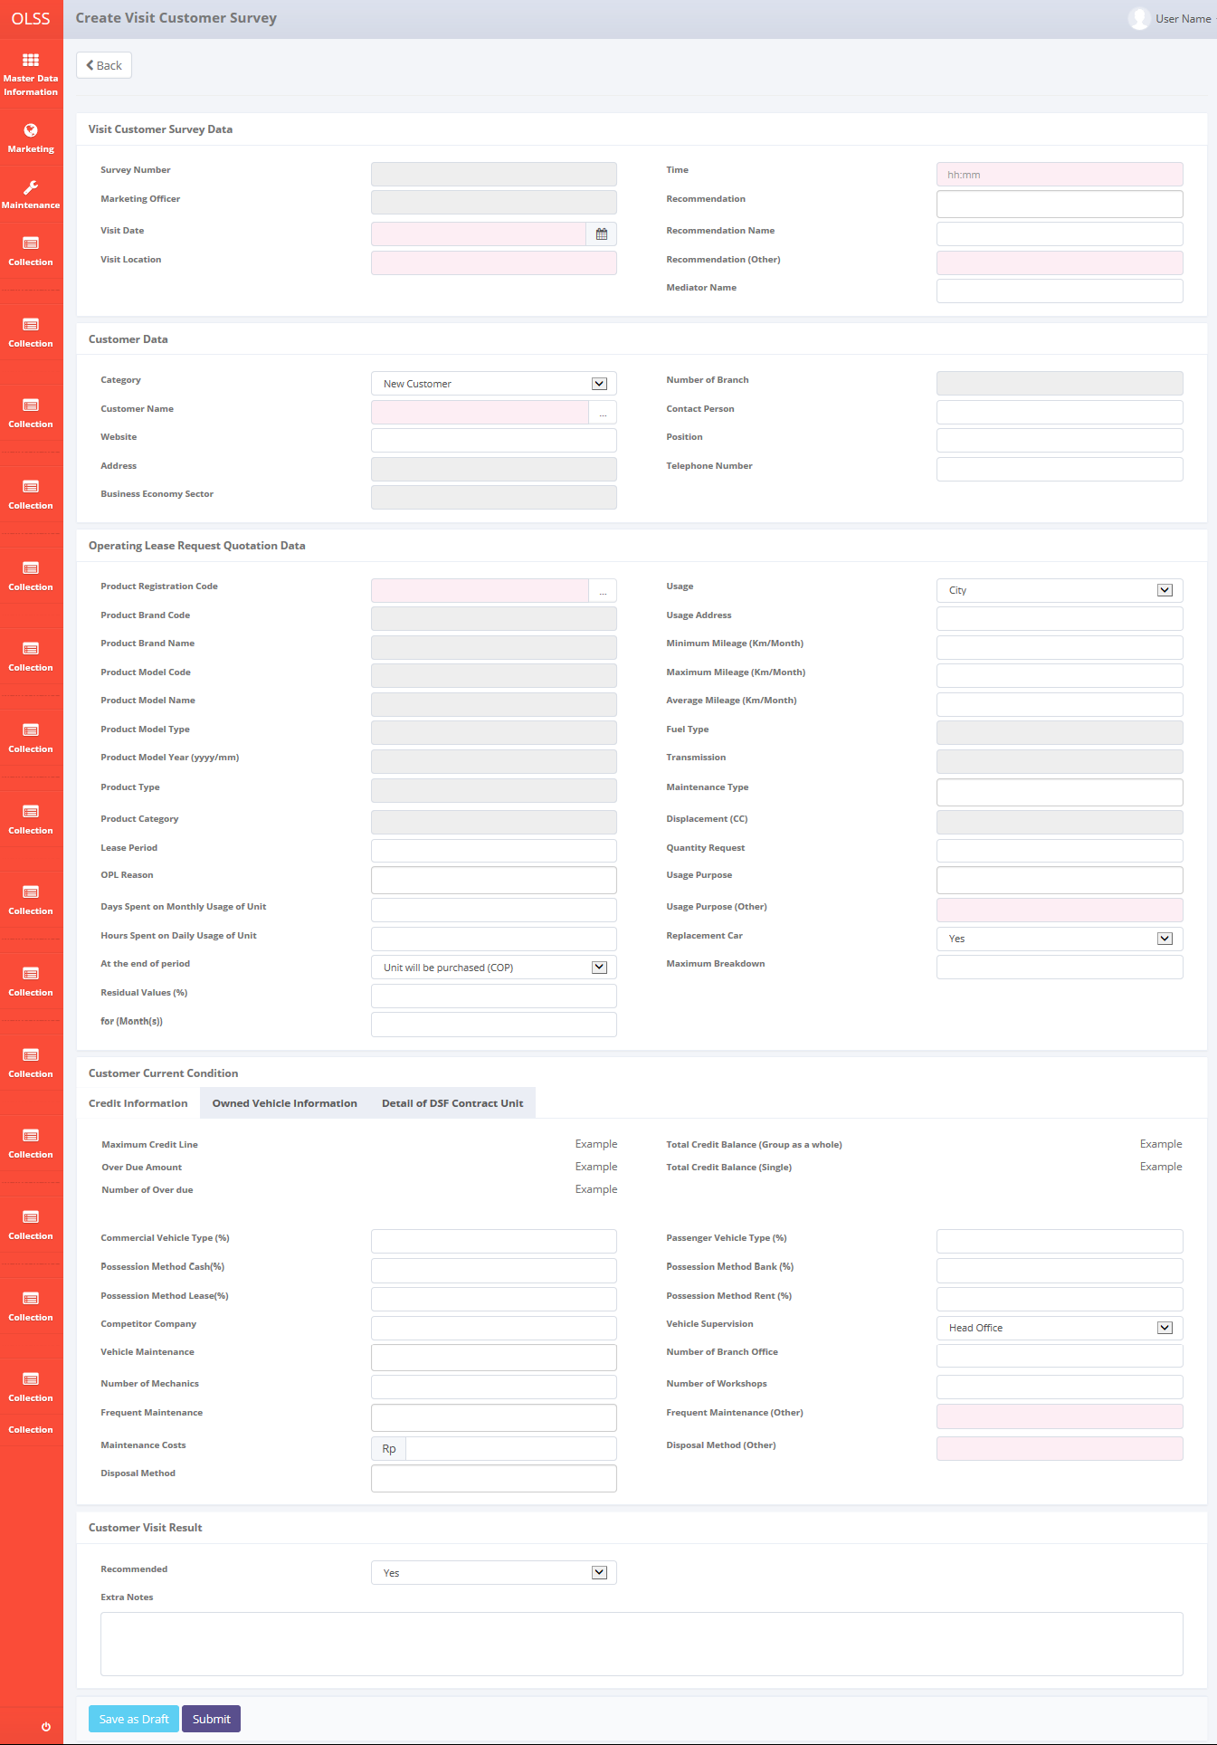

*Screen 2. Create Visit Customer Survey*

* *Edit Visit Customer Survey*

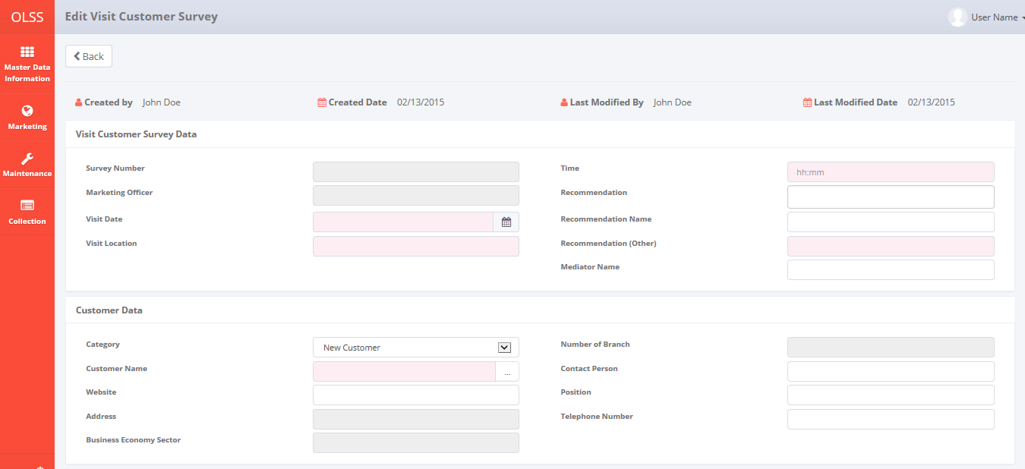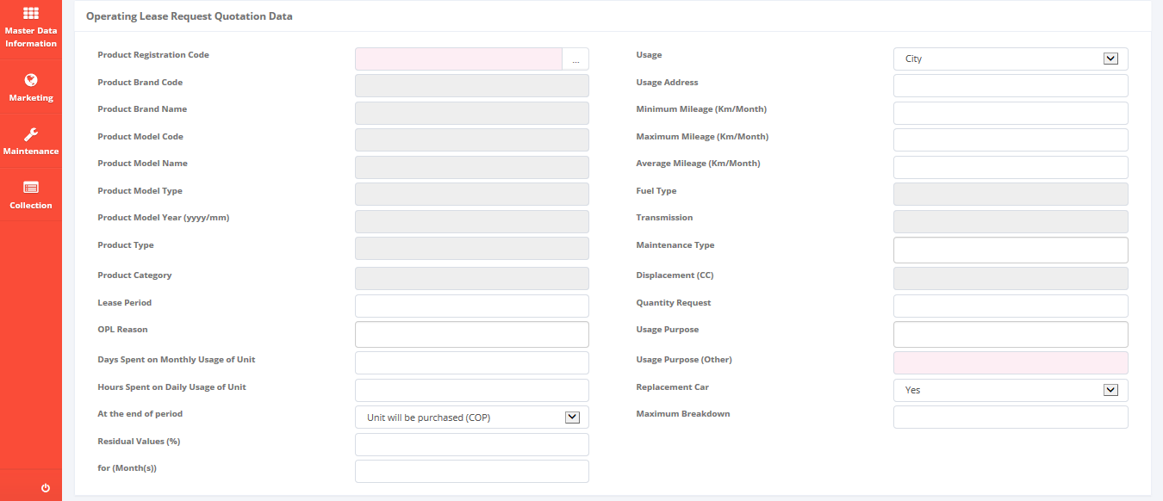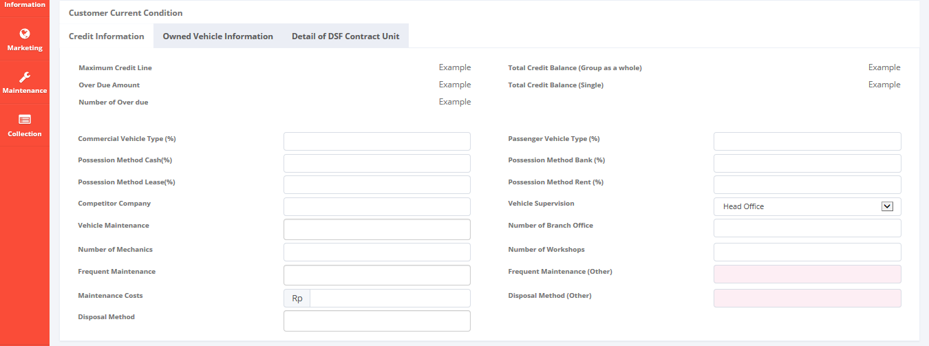 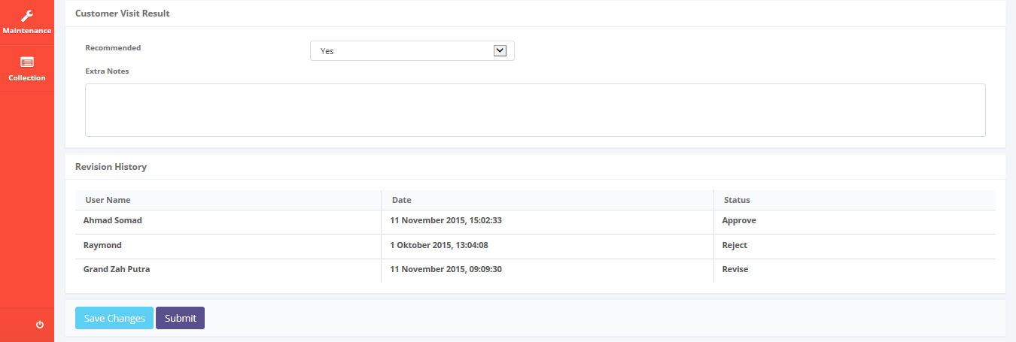

*Screen 3. Edit Visit Customer Survey*

* *View Visit Customer Survey*

*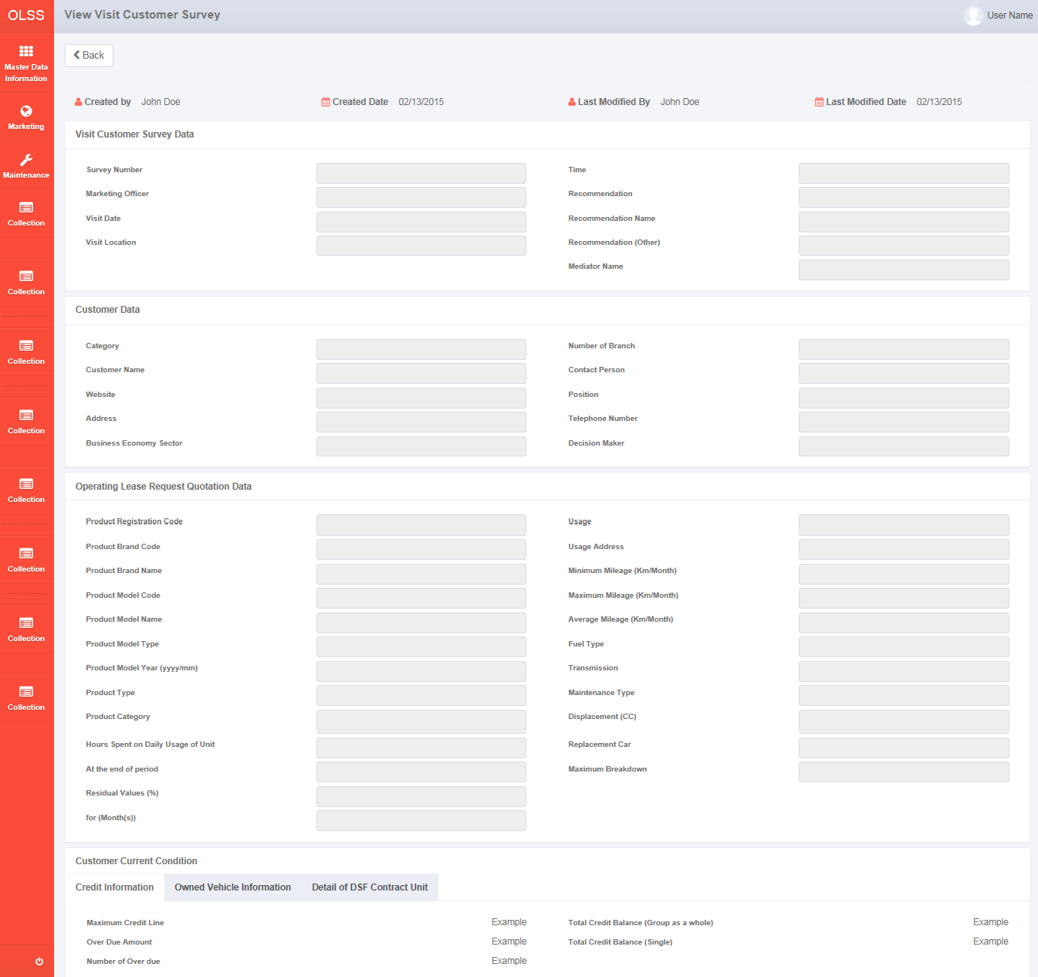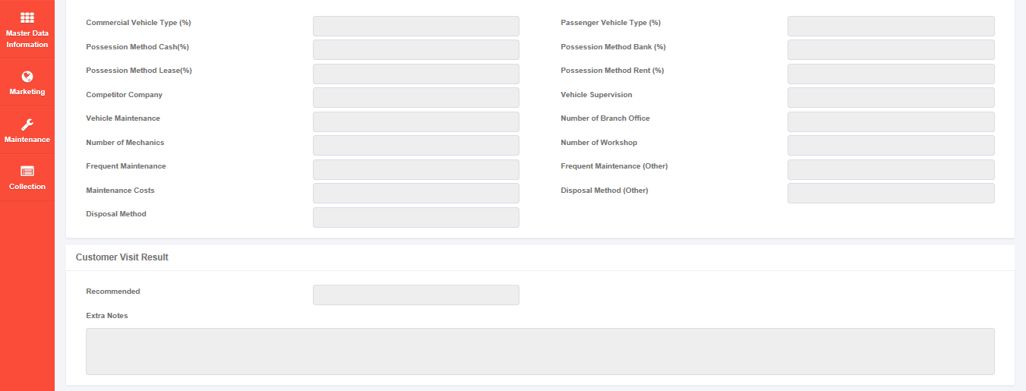 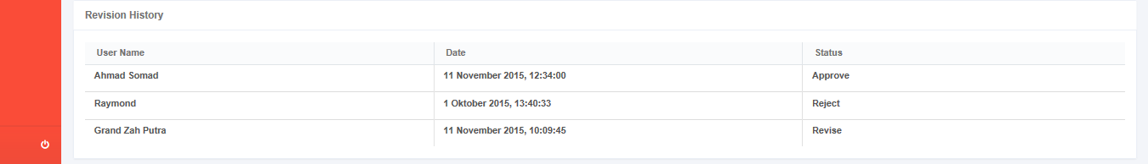*

*Screen 4. View Visit Customer Survey*

* *Print Form Visit Customer Survey*

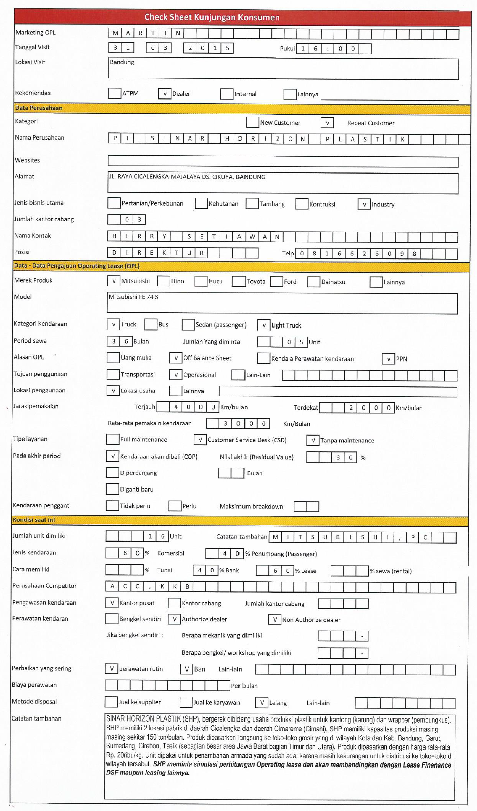

*Screen 5. Print Form Visit Customer Survey*

* *Email report of Visit Customer Survey*

*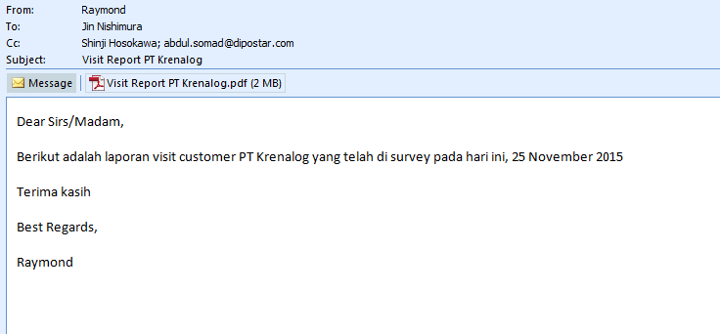*

*Screen 6. Email report of Visit Customer Survey*

* *Notification after Save or Submit Visit Customer Survey*

D:\Users\bsi00815\Desktop\PrintScreen\Message Survey.PNG

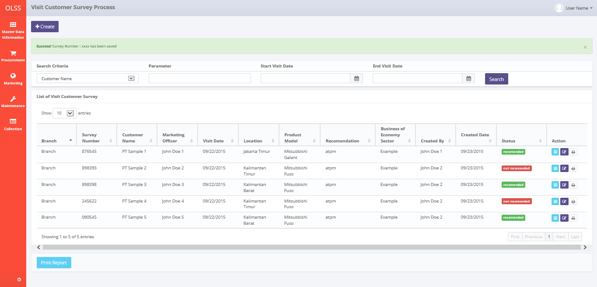

*Screen 7. Save or Submit Notification*

* 1. Component Screen Functionality
  2. **List of Visit Customer Survey**

Here are the screen functions from each component in **Screen 1. List of Visit Customer Survey**:

|  |  |  |  |
| --- | --- | --- | --- |
| ***No*** | ***Component*** | ***Name*** | ***Function*** |
| **Header** | | | |
| 1 | Label | List of Visit Customer Survey | Visit Customer Survey Creation title |
| 2 | Button | Create Visit Customer Survey Report | To select the operation for searching |
| **Search Criteria** | | | |
| 3 | Drop down box | Search criteria | To select the category for searching criteria |
| 4 | Text box/ Date picker | Parameter | To input the value for searching criteria |
| 5 | Date picker | Start Visit Date | To select the start date of record lists |
| 6 | Date picker | End Visit Date | To select the end date of record lists |
| 7 | Button | Search | To do a search and showing lists according to criteria |
| **List of Visit Customer Survey** | | | |
| 8 | Button | Edit Visit Customer Survey | To show an editable screen of Visit Customer Survey draft which has been created |
| 9 | Button | View Visit Customer Survey | To show details of Visit Customer Survey |
| 10 | Button | Print Form Visit Customer Survey | To show a preview of Visit Customer Survey report document before print |
| 11 | Drop down box | Entries | To show entry number of lists |
| 12 | Label | Branch | Display Branch of Visit Customer Survey that has been created |
| 13 | Button | Branch | To sort in ascending or descending format |
| 14 | Label | Survey Number | Display Survey Number of Visit Customer Survey that has been created |
| 15 | Button | Survey Number | To sort in ascending or descending format |
| 16 | Label | Customer Name | Display Customer Name of Visit Customer Survey that has been created |
| 17 | Button | Customer Name | To sort in ascending or descending format |
| 18 | Label | Visit Date | Display Visit Date of Visit Customer Survey that has been created |
| 19 | Button | Visit Date | To sort in ascending or descending format |
| 20 | Label | Location | Display Location of Visit Customer Survey that has been created |
| 21 | Button | Location | To sort in ascending or descending format |
| 22 | Label | Product Model | Display Product Model of Visit Customer Survey that has been created |
| 23 | Button | Product Model | To sort in ascending or descending format |
| 24 | Label | Recommendation | Display Recommendation of Visit Customer Survey that has been created |
| 25 | Button | Recommendation | To sort in ascending or descending format |
| 26 | Label | Business Economy Sector | Display Business Economy Sector of Visit Customer Survey that has been created |
| 27 | Button | Business Economy Sector | To sort in ascending or descending format |
| 28 | Label | Created By | Display Created By of Visit Customer Survey that has been created |
| 29 | Button | Created By | To sort in ascending or descending format |
| 30 | Label | Created Date | Display Created Date of Visit Customer Survey that has been created |
| 31 | Button | Created Date | To sort in ascending or descending format |
| 32 | Label | Status | Display Status of Visit Customer Survey that has been created |
| 33 | Button | Status | To sort in ascending or descending format |
| 34 | Label | Action | Display Edit, View, and Report button |
| 35 | Label | Showing 1 to *n* of *n* entries | Display the entries generated by search engine |
| 36 | Link | First Page | To show the first page entry |
| 37 | Link | Previous Page | To show the previous page entry |
| 38 | Link | Page Number | To show the page screen according the number |
| 39 | Link | Next Page | To show the next page entry |
| 40 | Link | Last Page | To show the last page entry |
| **Footer** | | | |
| 41 | Button | Print Report | To print the report from the lists of record |

* 1. **Create Visit Customer Survey**

Here are the screen functions from each component in **Screen 2. Create Visit Customer Survey**:

|  |  |  |  |
| --- | --- | --- | --- |
| ***No*** | ***Component*** | ***Name*** | ***Function*** |
| **Header** | | | |
| 1 | Label | Create Visit Customer Survey | Visit Customer Survey title |
| 2 | Button | Back | Back to previous screen |
| **Visit Customer Survey Data** | | | |
| 3 | Text Box | Survey Number | Displaying Survey Number (after save of submit) |
| 4 | Search box | Marketing Officer | To select the name of the marketing officer |
| 5 | Text Box | Recommendation | To input recommendation |
| 6 | Text Box | Recommendation Name | To input recommendation name |
| 7 | Text Box | Recommendation (other) | To input recommendation (other) |
| 8 | Text Box | Mediator Name | To input Mediator Name |
| 9 | Date Picker | Visit Date | To select visit date |
| 10 | Text Box | Visit Location | To input location of survey |
| **Customer Data** | | | |
| 11 | Label | Customer Data | Customer Data sub-title |
| 12 | Drop down box | Category | To select customer category |
| 13 | Search box | Customer Name | To search the name of customer |
| 14 | Text Box | Website | To input Website |
| 15 | Text Box | Address | Displaying customer address |
| 16 | Text Box | Business Economy Sector | Displaying Business Economy Sector |
| 17 | Text Box | Number of Branch | Displaying Number of Branch |
| 18 | Text Box | Contact Person | To input Contact Person |
| 19 | Text Box | Decision Maker | To input Decision Maker |
| 20 | Text Box | Position | To input Position |
| 21 | Text Box | Telephone Number | To input Telephone Number |
| **Operating Lease Request Quotation Data** | | | |
| 22 | Label | Operating Lease Request Quotation Data | Operating Lease Request Quotation Data sub-title |
| 23 | Search Box | Product Registration Code | To search Product Registration Code |
| 24 | Text Box | Product Type | Displaying Product Type |
| 25 | Text Box | Product Category | Displaying Product Category |
| 26 | Text Box | Product Brand Code | Displaying Product Brand Code |
| 27 | Text Box | Product Brand Name | Displaying Product Brand Name |
| 28 | Text Box | Product Model Code | Displaying Product Model Code |
| 29 | Text Box | Product Model Name | Displaying Product Model Name |
| 30 | Text Box | Product Model Type | Displaying Product Model Type |
| 31 | Text Box | Product Model Year (yyyy/mm) | Displaying Product Model Year (yyyy/mm) |
| 32 | Text Box | Lease Period | To input Lease Period |
| 33 | Text Box | Quantity Request | To input Quantity Request |
| 34 | Drop down box | OPL Reason | To select OPL Reason |
| 35 | Text Box | Usage Purpose | To select Usage Purpose |
| 36 | Text Box | Usage Purpose (Other) | To input Usage Purpose (Other) |
| 37 | Text Box | Transmission | Displaying Transmission |
| 38 | Text Box | Fuel Type | Displaying Fuel Type |
| 39 | Text Box | Displacement (CC) | Displaying Displacement (CC) |
| 40 | Drop down Box | Usage | To select Usage |
| 41 | Text Box | Usage Address | To input Usage Address |
| 42 | Drop down box | At the end of period | To select after the end of period |
| 43 | Text Box | Residual Values (%) | To input residual value |
| 44 | Text Box | For (months) | To input months |
| 45 | Text Box | Maximum Mileage (km/month) | To input Maximum Mileage |
| 46 | Text Box | Minimum Mileage (km/month) | To input Minimum Mileage |
| 47 | Text Box | Average Mileage (km/month) | To input Average Monthly Mileage |
| 48 | Text Box | Hours Spent on Daily Usage of Unit | To input Hours Spent on Daily Usage of Unit |
| 49 | Text Box | Days Spent on Monthly Usage of Unit | To input Days Spent on Monthly Usage of Unit |
| 50 | Drop down Box | Replacement Car | To select Replacement Car |
| 51 | Text Box | Maximum Breakdown | To input maximum breakdown |
| 52 | Drop down Box | Maintenance Type | To select Maintenance Type |
| 53 | Label | Customer Current Condition | Customer Current Condition sub-title |
| **Customer Current Condition** | | | |
| 54 | Tab | Credit Information | Credit Information tab |
| 55 | Label | Maximum Credit Line | Displaying Maximum Credit Line |
| 56 | Label | Total Creadit Balance (group as a whole) | Displaying Total Creadit Balance (group as a whole) |
| 57 | Label | Overdue amount | Displaying Overdue amount |
| 58 | Label | Total Credit Balance (Single) | Displaying Total Credit Balance (Single) |
| 58 | Label | Number of Overdue | Displaying Number of Overdue |
| 60 | Tab | Owned Vehicle Information | Owned Vehicle Information tab |
| 61 | Label | Customer Owned Unit – Number of Vehicle Unit | Displaying Customer Owned Unit – Number of Vehicle Unit |
| 62 | Label | Customer Owned Unit – Number of Forklift Unit | Displaying Customer Owned Unit – Number of Forklift Unit |
| 63 | Label | Customer Owned Unit – Number of HE Unit | Displaying Customer Owned Unit – Number of HE Unit |
| 64 | Label | DSF Contract Unit – Number of Vehicle Unit | Displaying DSF Contract Unit – Number of Vehicle Unit |
| 65 | Label | DSF Contract Unit – Number of Forklift Unit | Displaying DSF Contract Unit – Number of Forklift Unit |
| 66 | Label | DSF Contract Unit – Number of HE Unit | Displaying DSF Contract Unit – Number of HE Unit |
| 67 | Label | Potential Unit – Number of Vehicle Unit | Displaying Potential Unit – Number of Vehicle Unit |
| 68 | Label | Potential Unit – Number of Forklift Unit | Displaying Potential Unit – Number of Forklift Unit |
| 69 | Label | Potential Unit – Number of HE Unit | Displaying Potential Unit – Number of HE Unit |
| 70 | Label | Information Acquisition Date – Number of Vehicle Unit | Displaying Information Acquisition Date – Number of Vehicle Unit |
| 71 | Label | Information Acquisition Date – Number of Forklift Unit | Displaying Information Acquisition Date – Number of Forklift Unit |
| 72 | Label | Information Acquisition Date – Number of HE Unit | Displaying Information Acquisition Date – Number of HE Unit |
| 73 | Tab | Detail of DSF Contract Unit | Detail of DSF Contract Unit tab |
| 74 | Label | Operating Lease Non-Maintenance - LCV | Displaying Operating Lease Non-Maintenance - LCV |
| 75 | Label | Operating Lease Non-Maintenance – CV | Displaying Operating Lease Non-Maintenance – CV |
| 76 | Label | Operating Lease Non-Maintenance – PC | Displaying Operating Lease Non-Maintenance – PC |
| 77 | Label | Operating Lease Non-Maintenance – Forklift | Displaying Operating Lease Non-Maintenance – Forklift |
| 78 | Label | Operating Lease Non-Maintenance – HE | Displaying Operating Lease Non-Maintenance – HE |
| 79 | Label | Operating Lease Maintenance - LCV | Displaying Operating Lease Maintenance - LCV |
| 80 | Label | Operating Lease Maintenance – CV | Displaying Operating Lease Maintenance – CV |
| 81 | Label | Operating Lease Maintenance – PC | Displaying Operating Lease Maintenance – PC |
| 82 | Label | Operating Lease Maintenance – Forklift | Displaying Operating Lease Maintenance – Forklift |
| 83 | Label | Operating Lease Maintenance – HE | Displaying Operating Lease Maintenance – HE |
| 84 | Label | Operating Lease CSD - LCV | Displaying Operating Lease CSD - LCV |
| 85 | Label | Operating Lease CSD – CV | Displaying Operating Lease CSD – CV |
| 86 | Label | Operating Lease CSD – PC | Displaying Operating Lease CSD – PC |
| 87 | Label | Operating Lease CSD – Forklift | Displaying Operating Lease CSD – Forklift |
| 88 | Label | Operating Lease CSD – HE | Displaying Operating Lease CSD – HE |
| 89 | Label | Finance Lease - LCV | Displaying Finance Lease - LCV |
| 90 | Label | Finance Lease – CV | Displaying Finance Lease – CV |
| 91 | Label | Finance Lease – PC | Displaying Finance Lease – PC |
| 92 | Label | Finance Lease – Forklift | Displaying Finance Lease – Forklift |
| 93 | Label | Finance Lease – HE | Displaying Finance Lease – HE |
| 94 | Text Box | Vehicle Commercial Type (%) | To input Vehicle Commercial Type (%) |
| 95 | Text Box | Passenger Vehicle Type (%) | To input Passenger Vehicle Type (%) |
| 96 | Text Box | Possession Method Cash (%) | To input Possession Method Cash (%) |
| 97 | Text Box | Possession Method Bank (%) | To input Possession Method Bank (%) |
| 98 | Text Box | Possession Method Lease (%) | To input Possession Method Lease (%) |
| 99 | Text Box | Possession Method Rent (%) | To input Possession Method Rent (%) |
| 100 | Text Box | Competitor Company | To input the Competitor Company |
| 101 | Drop down box | Vehicle Maintenance | To select the Vehicle Maintenance |
| 102 | Text Box | Number of Mechanics | To input the Number of Mechanics |
| 103 | Text Box | Frequent Maintenance | To input the Frequent Maintenance |
| 104 | Text Box | Frequent Maintenance (other) | To input the Frequent Maintenance (other) |
| 105 | Drop down box | Disposal Method | To select the Disposal Method |
| 106 | Drop down box | Supervision Vehicle | To select the Supervision Vehicle |
| 107 | Text Box | Number of Branch Office | To input the Number of Branch Office |
| 108 | Text Box | Number of Workshops | To input the Number of Workshops |
| 109 | Text Box | Maintenance Costs | To input the Maintenance Costs |
| 110 | Text Box | Disposal Method (Other) | To input the Disposal Method (Other) |
| **Customer Visit Result** | | | |
| 111 | Label | Customer Visit Result | Customer Visit Result sub-title |
| 112 | Drop down box | Recommended | To select recommendation status |
| 113 | Text Area | Extra Notes | To input Extra Notes |
| **Footer** | | | |
| 114 | Button | Save as Draft | To save the inputted form as draft document |
| 115 | Button | Submit | To submit the inputted form |

* 1. **Edit Visit Customer Survey**

Here are the screen functions from each component in **Screen 3. Edit Visit Customer Survey**:

*See Component Screen Specification - b. Create Visit Customer Survey with addition of these components :*

|  |  |  |  |
| --- | --- | --- | --- |
| ***No*** | ***Component*** | ***Name*** | ***Function*** |
| **Header** | | | |
| 1 | Label | Edit Visit Customer Survey | Edit Visit Customer Survey title |
| 2 | Label | Created By | Displaying Created By |
| 3 | Label | Created Date | Displaying Created Date |
| 4 | Label | Last Modified By | Displaying Last Modified By |
| 5 | Label | Last Modified Date | Displaying Last Modified Date |
| **Revision History** | | | |
| 6 | Label | Revision History | Revision History sub-title |
| 7 | Label | User Name | Displaying User Name |
| 8 | Label | Date | Displaying Date |
| 9 | Label | Status | Displaying Status |
| **Footer** | | | |
| 10 | Button | Save Changes | To save the inputted form as draft document |

*and also this component is not available in Edit Visit Customer Survey :*

|  |  |  |  |
| --- | --- | --- | --- |
| ***No*** | ***Component*** | ***Name*** | ***Function*** |
| **Header** | | | |
| 1 | Label | Create Visit Customer Survey | Create Visit Customer Survey title |
| **Footer** | | | |
| 2 | Button | Save as Draft | To save the inputted form as draft document |

* 1. **View Visit Customer Survey**

Here are the screen functions from each component in **Screen 4. View Visit Customer Survey**:

*See Component Screen Specification - b. Create Visit Customer Survey with addition of these components :*

|  |  |  |  |
| --- | --- | --- | --- |
| ***No*** | ***Component*** | ***Name*** | ***Function*** |
| **Header** | | | |
| 1 | Label | View Visit Customer Survey | View Visit Customer Survey title |
| 2 | Label | Created By | Displaying Created By |
| 3 | Label | Created Date | Displaying Created Date |
| 4 | Label | Last Modified By | Displaying Last Modified By |
| 5 | Label | Last Modified Date | Displaying Last Modified Date |
| **Revision History** | | | |
| 6 | Label | Revision History | Revision History sub-title |
| 7 | Label | User Name | Displaying User Name |
| 8 | Label | Date | Displaying Date |
| 9 | Label | Status | Displaying Status |

*and also this component is not available in View Visit Customer Survey :*

|  |  |  |  |
| --- | --- | --- | --- |
| ***No*** | ***Component*** | ***Name*** | ***Function*** |
| **Header** | | | |
| 1 | Label | Create Visit Customer Survey | Create Visit Customer Survey title |
| **Footer** | | | |
| 2 | Button | Save as Draft | To save the inputted form as draft document |
| 3 | Button | Submit | To submit the inputted form |

* 1. **Email report Visit Customer Survey**

Here are the screen functions from each component in **Screen 6. Email report Visit Customer Survey**:

|  |  |  |  |
| --- | --- | --- | --- |
| ***No*** | ***Component*** | ***Name*** | ***Function*** |
| 1 | Label | To | Recipient of email |
| 2 | Label | Cc | Carbon copy recipient of the email |
| 3 | Label | Subject | Displaying Subject |
| 4 | File | Attachment | Attached Visit Customer Survey (.pdf) |
| 5 | Label | Body email | Body email |

* 1. Operation Description

|  |  |  |
| --- | --- | --- |
| **No.** | **Operation Name** | **Description** |
| 1 | Initial view of List of Visit Customer Survey | The screen for List of Visit Customer Survey:   1. Component Status;  |  |  |  |  | | --- | --- | --- | --- | | Component | Name/Caption | Status | Remark | | Label | List of Visit Customer Survey | Not Active |  | | Button | Create Visit Customer Survey Report | Active | Button to Create Visit Customer Survey | | Drop down box | Search criteria | Active | Lists of search criteria the same with header of table lists | | Text box/ Date picker | Parameter | Active | Component will change based on search criteria type | | Date picker | Start Date | Active |  | | Date picker | End Date | Active |  | | Button | Search | Active |  | | Button | Edit Visit Customer Survey | Active | Button to Create Visit Customer Survey | | Button | View Visit Customer Survey | Active | Button to View Visit Customer Survey | | Button | Print Form Visit Customer Survey | Active | Button to Print the form of Visit Customer Survey | | Drop down box | Entries | Active | Showing the number of lists displayed in each page | | Label | Branch | Not Active |  | | Button | Branch | Active | Header for sort feature | | Label | Survey Number | Not Active |  | | Button | Survey Number | Active | Header for sort feature | | Label | Customer Name | Not Active |  | | Button | Customer Name | Active | Header for sort feature | | Label | Visit Date | Not Active |  | | Button | Visit Date | Active | Header for sort feature | | Label | Location | Not Active |  | | Button | Location | Active | Header for sort feature | | Label | Product Model | Not Active |  | | Button | Product Model | Active | Header for sort feature | | Label | Recommendation | Not Active |  | | Button | Recommendation | Active | Header for sort feature | | Label | Business Economy Sector | Not Active |  | | Button | Business Economy Sector | Active | Header for sort feature | | Label | Created By | Not Active |  | | Button | Created By | Active | Header for sort feature | | Label | Created Date | Not Active |  | | Button | Created Date | Active | Header for sort feature | | Label | Status | Not Active |  | | Button | Status | Active | Header for sort feature | | Label | Action | Not Active |  | | Label | Showing 1 to *n* of *n* entries | Not Active |  | | Link | First Page | Active | Active depending on the current | | Link | Previous Page | Active | Active depending on the current | | Link | Page Number | Active | Active depending on the current entry | | Link | Next Page | Active | Active depending on the current entry | | Link | Last Page | Active | Active depending on the current entry | | Button | Print Report | Active |  | |
| 2 | Searching the List of Visit Customer Survey | Input:   1. Select searching criteria category (search criteria), searching criteria value (parameter), Start Period (Visit Date), and End Period (Visit Date) in the Search Field   D:\Users\bsi00815\AppData\Local\Microsoft\Windows\Temporary Internet Files\Content.Word\VCS_List.png  Constraint:   1. Search criteria only consists of Customer Name, Location, Product Model, Branch, Survey Number, Marketing Officer, Recommendation, and Business Economy Sector (the same as the lists) generated from Tb\_OPL\_SearchCriteria mapping 2. End Period can not be less than Start Visit Date (the End Visit Date will be locked for the date before Start Visit Date) 3. Start Period can not be less than End Visit Date (the Start Visit Date will be locked for the date after End Visit Date) 4. Click on the Search button   D:\Users\bsi00815\AppData\Local\Microsoft\Windows\Temporary Internet Files\Content.Word\Visit Customer Survey Report.png   1. The screen will view the list of Visit Customer Survey according to criteria 2. Select number of show list entries: 10, 25, 50, and 100 and click the page for viewing more data.   Process:   1. After Clicking the search button, the system will get the data from Tb\_MKT\_VisitCustSurvey table, Customer table, Product table, Employee table, and Branch table to be displayed in the list   Output:   1. Display list data of Visit Customer Survey |
| 3 | Initial view of Create Visit Customer Survey | The screen for Create Visit Customer Survey:   1. Status component;  |  |  |  |  | | --- | --- | --- | --- | | Component | Name/Caption | Status | Remark | | Label | Create Visit Customer Survey | Not Active |  | | Button | Back | Active |  | | Text Box | Survey Number | Not Active |  | | Text Box | Marketing Officer | Not Active | Mandatory field marked as red | | Text Box | Time | Active | Mandatory field marked as red | | Text Box | Recommendation | Active |  | | Text Box | Recommendation Name | Active | Mandatory field marked as red | | Text Box | Recommendation (other) | Active | Populated if "Recommendation” field is filled with “Other” | | Text Box | Mediator Name | Active |  | | Date Picker | Visit Date | Active | Mandatory field marked as red | | Text Box | Visit Location | Active | Mandatory field marked as red | | Label | Customer Data | Not Active |  | | Drop down box | Category | Active |  | | Search box | Customer Name | Active | Mandatory field marked as red | | Text Box | Website | Active |  | | Text Box | Address | Not Active |  | | Text Box | Business Economy Sector | Not Active |  | | Text Box | Number of Branch | Not Active |  | | Text Box | Contact Person | Active |  | | Text Box | Decision Maker | Active |  | | Text Box | Position | Active |  | | Text Box | Telephone Number | Active |  | | Label | Operating Lease Request Quotation Data | Not Active |  | | Search Box | Product Registration Code | Active | Mandatory field marked as red | | Text Box | Product Type | Not Active |  | | Text Box | Product Category | Not Active |  | | Text Box | Product Brand Code | Not Active |  | | Text Box | Product Brand Name | Not Active |  | | Text Box | Product Model Code | Not Active |  | | Text Box | Product Model Name | Not Active |  | | Text Box | Product Model Type | Not Active |  | | Text Box | Product Model Year (yyyy/mm) | Not Active |  | | Text Box | Lease Period | Active |  | | Text Box | Quantity Request | Active | Populated if "Lease Period” field is filled with “Other”  (Mandatory depicted in red) | | Drop down box | OPL Reason | Active |  | | Text Box | Usage Purpose | Active |  | | Text Box | Usage Purpose (Other) | Active | Populated if "Usage Purpose” field is filled with “Other”  (Mandatory depicted in red) | | Text Box | Transmission | Not Active |  | | Text Box | Fuel Type | Not Active |  | | Text Box | Displacement (CC) | Not Active |  | | Drop down Box | Usage | Active |  | | Text Box | Usage Address | Active |  | | Drop down box | At the end of period | Active |  | | Text Box | Residual Values (%) | Active | Populated if "At the end of period” field is filled with “Unit will be purchased (COP)”  (Mandatory depicted in red) | | Text Box | For (month(s)) | Active | Populated if "At the end of period” field is filled with “Unit will be extended”  (Mandatory depicted in red) | | Text Box | Maximum Mileage (km/month) | Active |  | | Text Box | Minimum Mileage (km/month) | Active |  | | Text Box | Average Mileage (km/month) | Active |  | | Text Box | Hours Spent on Daily Usage of Unit | Active |  | | Text Box | Days Spent on Monthly Usage of Unit | Active |  | | Drop down Box | Replacement Car | Active |  | | Text Box | Maximum Breakdown | Active | Populated if "Maximum Breakdown” field is filled with “Yes”  (Mandatory depicted in red) | | Drop down Box | Maintenance Type | Active |  | | Label | Customer Current Condition | Not Active |  | | Tab | Credit Information | Not Active |  | | Label | Maximum Credit Line | Not Active |  | | Label | Total Credit Balance (group as a whole) | Not Active |  | | Label | Overdue amount | Not Active |  | | Label | Total Credit Balance (Single) | Not Active |  | | Label | Number of Overdue | Not Active |  | | Tab | Owned Vehicle Information | Not Active |  | | Label | Customer Owned Unit – Number of Vehicle Unit | Not Active |  | | Label | Customer Owned Unit – Number of Forklift Unit | Not Active |  | | Label | Customer Owned Unit – Number of HE Unit | Not Active |  | | Label | DSF Contract Unit – Number of Vehicle Unit | Not Active |  | | Label | DSF Contract Unit – Number of Forklift Unit | Not Active |  | | Label | DSF Contract Unit – Number of HE Unit | Not Active |  | | Label | Potential Unit – Number of Vehicle Unit | Not Active |  | | Label | Potential Unit – Number of Forklift Unit | Not Active |  | | Label | Potential Unit – Number of HE Unit | Not Active |  | | Label | Information Acquisition Date – Number of Vehicle Unit | Not Active |  | | Label | Information Acquisition Date – Number of Forklift Unit | Not Active |  | | Label | Information Acquisition Date – Number of HE Unit | Not Active |  | | Tab | Detail of DSF Contract Unit | Not Active |  | | Label | Operating Lease Non-Maintenance - LCV | Not Active |  | | Label | Operating Lease Non-Maintenance – CV | Not Active |  | | Label | Operating Lease Non-Maintenance – PC | Not Active |  | | Label | Operating Lease Non-Maintenance – Forklift | Not Active |  | | Label | Operating Lease Non-Maintenance – HE | Not Active |  | | Label | Operating Lease Maintenance - LCV | Not Active |  | | Label | Operating Lease Maintenance – CV | Not Active |  | | Label | Operating Lease Maintenance – PC | Not Active |  | | Label | Operating Lease Maintenance – Forklift | Not Active |  | | Label | Operating Lease Maintenance – HE | Not Active |  | | Label | Operating Lease CSD - LCV | Not Active |  | | Label | Operating Lease CSD – CV | Not Active |  | | Label | Operating Lease CSD – PC | Not Active |  | | Label | Operating Lease CSD – Forklift | Not Active |  | | Label | Operating Lease CSD – HE | Not Active |  | | Label | Finance Lease - LCV | Not Active |  | | Label | Finance Lease – CV | Not Active |  | | Label | Finance Lease – PC | Not Active |  | | Label | Finance Lease – Forklift | Not Active |  | | Label | Finance Lease – HE | Not Active |  | | Text Box | Vehicle Commercial Type (%) | Active |  | | Text Box | Passenger Vehicle Type (%) | Active |  | | Text Box | Possession Method Cash (%) | Active |  | | Text Box | Possession Method Bank (%) | Active |  | | Text Box | Possession Method Lease (%) | Active |  | | Text Box | Possession Method Rent (%) | Active |  | | Text Box | Competitor Company | Active |  | | Drop down box | Vehicle Maintenance | Active |  | | Text Box | Number of Mechanics | Active |  | | Text Box | Frequent Maintenance | Active |  | | Text Box | Frequent Maintenance (Other) | Active | Populated if " Frequent Maintenance” field is filled with “Other”  (Mandatory depicted in red) | | Drop down box | Disposal Method | Active |  | | Drop down box | Vehicle Supervision | Active |  | | Text Box | Number of Branch Office | Active | Populated if "Vehicle Supervision” field is filled with “Branch Office”  (Mandatory depicted in red) | | Text Box | Number of Workshops | Active | Populated if "Vehicle Supervision” field is filled with “Own workshop”  (Mandatory depicted in red) | | Text Box | Number of Mechanics | Active | Populated if "Vehicle Supervision” field is filled with “Own workshop”  (Mandatory depicted in red) | | Text Box | Maintenance Costs | Active |  | | Text Box | Disposal Method (Other) | Active | Populated if "Disposal Method” field is filled with “Other”  (Mandatory depicted in red) | | Label | Customer Visit Result | Active |  | | Drop down box | Recommended | Active |  | | Text Area | Extra Notes | Active |  | | Button | Save as Draft | Active |  | | Button | Submit | Active |  | |
| 4 | Create Visit Customer Survey | Input:   1. Click the button Create Visit Customer Survey on the List of Visit Customer Survey screen      1. Input/ select the following field:  * Time * Recommendation * Recommendation Name * Recommendation (other) * Visit Date * Visit Location * Category * Customer Name * Website * Contact Person * Decision Maker * Position * Telephone Number * Product Registration Code * Lease Period * Quantity Request * OPL Reason * Usage Purpose * Usage Purpose (Other) * Usage * Usage Address * At the end of period * Residual Values (%) * For (months) * Maximum Mileage (km/month) * Minimum Mileage (km/month) * Average Mileage (km/month) * Hours Spent on Daily Usage of Unit * Days Spent on Monthly Usage of Unit * Replacement Car * Maximum Breakdown * Maintenance Type * Vehicle Commercial Type (%) * Passenger Vehicle Type (%) * Possession Method Cash (%) * Possession Method Bank (%) * Possession Method Lease (%) * Possession Method Rent (%) * Competitor Company * Vehicle Maintenance * Number of Mechanics * Frequent Maintenance * Frequent Maintenance (Other) * Disposal Method * Vehicle Supervision * Number of Branch Office * Number of Workshops * Number of Mechanics * Maintenance Costs * Disposal Method (Other) * Customer Visit Result * Recommended * Extra Notes   Constraint:   1. Hint “Input with number” will appear for Telephone Number, Maximum Mileage, Monthly Mileage, Average Monthly Mileage, Days Spent on Monthly Usage of Unit, Hours Spent on Daily Usage of Unit, Number of Branch Unit, Number of Workshop,and Number of Mechanics if the user clicked onto the field 2. Hint “24 hours format” will appear if the user clicked onto the Time field 3. Several field will be populated if a certain value is selected (refer to Initial screen on Create Visit Customer Survey) 4. Date Picker component will initially select today’s system date 5. Telephone Number is a varchar but cannot be inputted by characters (characters cannot be inputted) 6. Number of Branch, Monthly Mileage, Maximum Mileage, Minimum Mileage, Average Monthly Mileage, Hours Spent on Daily Usage of Unit, and Days Spent on Monthly Usage of Unit can only be inputted with integer/ number (characters cannot be inputted) 7. Every field inputted cannot exceed maximum length defined in database system 8. From step 2, click on Save as Draft button to save the document in draft status   D:\Users\bsi00815\AppData\Local\Microsoft\Windows\Temporary Internet Files\Content.Word\VCS_Create.png  Constraint:   1. If clicked with any of the field still hasn’t meet the validation criteria, every notification message for validation below the field will be generated 2. Clicking the button will trigger a pop up screen for validation “**Are you sure you want to Save?**” 3. From step 2, click on Submit button to submit the document for next process and change the status of document into Recommended or Not recommended according to Recommended field value   D:\Users\bsi00815\AppData\Local\Microsoft\Windows\Temporary Internet Files\Content.Word\VCS_Edit.png  Constraint:   1. If clicked with any of the field still hasn’t meet the validation criteria, every notification message for validation below the field will be generated 2. Clicking the button will trigger a pop up screen for validation “**Are you sure you want to Submit?**”   Process:   1. Selecting Marketing Officer will generate Employee Name from Tb\_OPL\_Employee.EmployeeName (related to UserName) 2. Selecting Customer Name will automatically get data from Customer table for Address, Business Economy Sector, Number of Branch in Customer Data. Data information for Customer Current Condition in Credit Information, Owned Vehicle Information, and Detail of DSF Contract Unit are all extracted from Customer table 3. Selecting Product Registration Code will get data from Product Brand table, Product Category table, Product Model table, and Product Type table for Product Type, Product Category, Product Brand Code, Product Brand Name, Product Model Code, Product Model Name, Product Model Type, Product Model Year (yyyy/mm), Transmission, Fuel Type, Displacement (CC) 4. Selecting the OPL Reason field with “Other” value will activate the OPL Reason (other) field 5. Selecting the Recommendation field with “Other” value will activate the Recommendation (other) field 6. Selecting the Disposal method with “Other” value will activate the Disposal Method (other) field 7. Selecting the Frequent Maintenance with “Other” value will activate the Frequent Maintenance (other) field 8. Selecting the Replacement Car with “Yes” value will activate the Maximum Breakdown field 9. Selecting the Usage Purpose with “Other” value will activate the Usage Purpose (other) field 10. Selecting the Vehicle Supervision with “Branch Office” value will activate the Number of Branch Office field 11. Selecting the Vehicle Maintenance with “Own Workshop” value will activate the Number of Mechanics and Number of Workshops field 12. Selecting At the end of period with “Will be purchased” value will activate the Residual Value field 13. Selecting At the end of period with “Will be extended” value will activate the for (month(s)) field 14. Revision Log will be inserted with the User Name, Date, and Status of the last activity from Tb\_MKT\_VisitCustSurveyLog   Status consists of:   * Update (when button Save as Draft or Save Changes is clicked) * Submit (when button Submit is clicked) * Check (when button Check is clicked) * Approve (when button Approve is clicked) * Reject (when button Reject is clicked) * Revise (when button Revise is clicked)   Output:   1. By clicking save as draft or submit, the inputted data will be inserted into Tb\_MKT\_VisitCustSurvey table and generate a Survey Number with a notification “**Success!** Survey Number : xxxx has been saved” (xxxx refers to Tb\_MKT\_VisitCustSurvey.SurveyNo) 2. List of Visit Customer Survey screen will be added by new data with the status “Draft” for a record that has been “Save as Draft” or “Save Changes”, status “Recommended” for a record that has been “Submit” and the Recommended field has been selected with “Yes”, and status “Not Recommended” for a record that has been “Submit” and the Recommended field has been selected with “No” 3. The data of current User Name, last update time, and status will be recorded into Tb\_MKT\_VisitCustSurveyLog   Constraint:   1. The output won’t be generated if there are still at least one mandatory field which hasn’t been inputted. An error message for each one of the field will be depicted in red below each of the mandatory field (notification “This field is required” for mandatory field)   Alternative:   1. From step 2, click on Back button to go back to previous menu (List of Visit Customer Survey) |
| 5 | Initial view of Edit Visit Customer Survey | The screen for Edit Visit Customer Survey:   1. Status component;   *See Create Visit Customer Survey status component with addition of these components:*   |  |  |  |  | | --- | --- | --- | --- | | Component | Name/Caption | Status | Remark | | Label | Edit Visit Customer Survey | Not Active |  | | Label | Created By | Not Active |  | | Label | Created Date | Not Active |  | | Label | Last Modified By | Not Active |  | | Label | Last Modified Date | Not Active |  | | Label | Revision History | Not Active |  | | Label | User Name | Not Active | Displayed according to last username who updated the document (get from Tb\_MKT\_VisitCustSurveyLog) | | Label | Date | Not Active | Displayed according to last datetime the last username who updated the document (get from Tb\_MKT\_VisitCustSurveyLog) | | Label | Status | Not Active | Displayed according to last activity the last username who updated the document (get from Tb\_MKT\_VisitCustSurveyLog) | | Button | Save Changes | Active |  | |
| 6 | Edit Visit Customer Survey | Input:   1. Click the button Edit Visit Customer Survey on the List of Visit Customer Survey screen   D:\Users\bsi00815\Desktop\PrintScreen\Edit button.png   1. Update the following field (if needed):  * Time * Recommendation * Recommendation Name * Recommendation (other) * Visit Date * Visit Location * Category * Customer Name * Website * Contact Person * Decision Maker * Position * Telephone Number * Product Registration Code * Lease Period * Quantity Request * OPL Reason * Usage Purpose * Usage Purpose (Other) * Usage * Usage Address * At the end of period * Residual Values (%) * For (months) * Maximum Mileage (km/month) * Minimum Mileage (km/month) * Average Mileage (km/month) * Hours Spent on Daily Usage of Unit * Days Spent on Monthly Usage of Unit * Replacement Car * Maximum Breakdown * Maintenance Type * Vehicle Commercial Type (%) * Passenger Vehicle Type (%) * Possession Method Cash (%) * Possession Method Bank (%) * Possession Method Lease (%) * Possession Method Rent (%) * Competitor Company * Vehicle Maintenance * Number of Mechanics * Frequent Maintenance * Frequent Maintenance (Other) * Disposal Method * Vehicle Supervision * Number of Branch Office * Number of Workshops * Number of Mechanics * Maintenance Costs * Disposal Method (Other) * Customer Visit Result * Recommended * Extra Notes   Constraint:   1. Hint “Input with number” will appear for Telephone Number, Maximum Mileage, Monthly Mileage, Average Monthly Mileage, Days Spent on Monthly Usage of Unit, Hours Spent on Daily Usage of Unit, Number of Branch Unit, Number of Workshop,and Number of Mechanics if the user clicked onto the field 2. Hint “24 hours format” will appear if the user clicked onto the Time field 3. Several field will be populated if a certain value is selected (refer to Initial screen on Create Visit Customer Survey) 4. Date Picker component will initially select today’s system date 5. Telephone Number is a varchar but cannot be inputted by characters (characters cannot be inputted) 6. Number of Branch, Monthly Mileage, Maximum Mileage, Minimum Mileage, Average Monthly Mileage, Hours Spent on Daily Usage of Unit, and Days Spent on Monthly Usage of Unit can only be inputted with integer/ number (characters cannot be inputted) 7. Every field inputted cannot exceed maximum length defined in database system 8. From step 2, click on Save Changes button to save the document in draft status   D:\Users\bsi00815\AppData\Local\Microsoft\Windows\Temporary Internet Files\Content.Word\VCS_Edit.png  Constraint:   1. If clicked with any of the field still hasn’t meet the validation criteria, every notification message for validation below the field will be generated (notification “This field is required” for mandatory field) 2. Clicking the button will trigger a pop up screen for validation “**Are you sure you want to Save?**” 3. From step 2, click on Submit button to submit the document for next process   D:\Users\bsi00815\AppData\Local\Microsoft\Windows\Temporary Internet Files\Content.Word\VCS_Edit.png  Constraint:   1. If clicked with any of the field still hasn’t meet the validation criteria, every notification message for validation below the field will be generated 2. Clicking the button will trigger a pop up screen for validation “**Are you sure you want to Submit?**”   Process:   1. Inputting Customer Name will automatically get data from Customer table for Address, Business Economy Sector, Number of Branch in Customer Data. Data information for Customer Current Condition in Credit Information, Owned Vehicle Information, and Detail of DSF Contract Unit are all extracted from Customer table 2. Inputting Product Registration Code will get data from Product Brand table, Product Category table, Product Model table, and Product Type table for Product Type, Product Category, Product Brand Code, Product Brand Name, Product Model Code, Product Model Name, Product Model Type, Product Model Year (yyyy/mm), Transmission, Fuel Type, Displacement (CC) 3. Selecting the OPL Reason field with “Other” value will activate the OPL Reason (other) field 4. Selecting the Recommendation field with “Other” value will activate the Recommendation (other) field 5. Selecting the Disposal method with “Other” value will activate the Disposal Method (other) field 6. Selecting the Frequent Maintenance with “Other” value will activate the Frequent Maintenance (other) field 7. Selecting the Replacement Car with “Yes” value will activate the Maximum Breakdown field 8. Selecting the Usage Purpose with “Other” value will activate the Usage Purpose (other) field 9. Selecting the Usage Purpose with “Branch Office” value will activate the Number of Branch Office field 10. Selecting the Vehicle Maintenance with “Own Workshop” value will activate the Number of Mechanics and Number of Workshops field 11. Selecting At the end of period with “Will be purchased” value will activate the Residual Value field 12. Selecting At the end of period with “Will be extended” value will activate the for (month(s)) field 13. Revision Log will be inserted with the User Name, Date, and Status of the last activity from Tb\_MKT\_VisitCustSurveyLog   Status consists of:   * Update (when button Save as Draft or Save Changes is clicked) * Submit (when button Submit is clicked) * Check (when button Check is clicked) * Approve (when button Approve is clicked) * Reject (when button Reject is clicked) * Revise (when button Revise is clicked)   Output:   1. By clicking save changes or submit, the inputted data will update the Tb\_MKT\_VisitCustSurvey table. 2. An email will be sent to Distribution List which has been set in “Setting Email Visit Customer Survey List” (see Functional Specification FC.C.1 System Setting) *See 3.5 Screen Design - Screen 6. Email report of Visit Customer Survey* 3. List of Visit Customer Survey screen will be added by new data with the status “Draft” for a record that has been “Save as Draft” or “Save Changes”, status “Recommended” for a record that has been “Submit” and the Recommended field has been selected with “Yes”, and status “Not Recommended” for a record that has been “Submit” and the Recommended field has been selected with “No”   Constraint:   1. The output won’t be generated if there are still at least one mandatory field which hasn’t been inputted or the value inputted reached maximum length of the characters. An error message for each one of the field will be generated in red   Alternative:   1. From step 20, click on Back button to go back to previous menu (List of Visit Customer Survey) |
| 7 | Initial view of View Visit Customer Survey | The screen for View Visit Customer Survey:   1. Status component;   *See Create Visit Customer Survey status component (****all status not active****) with addition of these components:*   |  |  |  |  | | --- | --- | --- | --- | | Component | Name/Caption | Status | Remark | | Label | View Visit Customer Survey | Not Active |  | | Label | Created By | Not Active |  | | Label | Created Date | Not Active |  | | Label | Last Modified By | Not Active |  | | Label | Last Modified Date | Not Active |  | | Label | Revision History | Not Active |  | | Label | User Name | Not Active | Displayed according to last username who updated the document (get from Tb\_MKT\_VisitCustSurveyLog) | | Label | Date | Not Active | Displayed according to last datetime the last username who updated the document (get from Tb\_MKT\_VisitCustSurveyLog) | | Label | Status | Not Active | Displayed according to last activity the last username who updated the document (get from Tb\_MKT\_VisitCustSurveyLog) | |
| 8 | View Visit Customer Survey | Input:   1. Click the button View Visit Customer Survey on the List of Visit Customer Survey screen   D:\Users\bsi00815\AppData\Local\Microsoft\Windows\Temporary Internet Files\Content.Word\Customer_Visit_Survey_List.png  Process:   1. The data on the View screen are extracted from Employee, Customer, Product, Branch, and Tb\_MKT\_VisitCustSurvey table   Output:   1. The screen displays the Data from Employee, Customer, Product, Branch, and Tb\_MKT\_VisitCustSurvey table   Altenative:   1. From step 1, click on Back button to go back to previous menu (List of Visit Customer Survey) |
| 9 | Initial Print Form Visit Customer Survey | The screen for Print Form Visit Customer Survey:   1. Status component;   *See Create Visit Customer Survey status component (****all status not active with label component****) with addition of these components:*   |  |  |  |  | | --- | --- | --- | --- | | Component | Name/Caption | Status | Remark | | Label | Print Form Visit Customer Survey | Not Active |  | | Label | Created By | Not Active |  | | Label | Created Date | Not Active |  | | Label | Last Modified By | Not Active |  | | Label | Last Modified Date | Not Active |  | | Label | Revision History | Not Active |  | | Label | User Name | Not Active |  | | Label | Date | Not Active |  | | Label | Status | Not Active |  | |
| 10 | Print Form Visit Customer Survey | Input:   1. Click the button Print Form Visit Customer Survey on the List of Visit Customer Survey screen   D:\Users\bsi00815\AppData\Local\Microsoft\Windows\Temporary Internet Files\Content.Word\VCS_List.png  Process:   1. The data on the View screen are extracted from Customer, Product, and Tb\_MKT\_VisitCustSurvey table   Output:   1. The screen displays the Data from Customer, Product, and Tb\_MKT\_VisitCustSurvey table 2. Print out Form **PF.AB.1.1 Visit Customer Survey Form**   Altenative:   1. From step 1, click on Back button to go back to previous menu (List of Visit Customer Survey) 2. Convert to excel/ pdf with the drop down button and the output will follow the predefined design |
| 11 | Print Visit Customer Survey report | Input:   1. *Operation Name 2. Create Visit Customer Survey* 2. Click button Print Report   D:\Users\bsi00815\AppData\Local\Microsoft\Windows\Temporary Internet Files\Content.Word\SKD_List.png  Process:  *-*  Output:   1. Print out report list **RPT.AB.1.1 Visit Customer Survey Report** |
| 12 | System error message | Process:   1. Any errors outside of application validation or that which cannot be handled by application such as errors when communicating with database, bugs, overloop, etc will generate an error message “System error. Please contact your administrator”   Output:   1. A page with system error message will appear. |

* 1. Screen Item List

**PF.AB.1.1 Visit Customer Survey Form**

|  |  |  |  |  |
| --- | --- | --- | --- | --- |
| *No.* | *Content* | *Description* | *Source* | *Remarks* |
| 1 | Form Title | Check Sheet Kunjungan Konsumen |  |  |
| 2 | Marketing OPL | Marketing Officer | Tb\_OPL\_Employee.EmployeeName | *Where*  *User.IdEmployee = Employee.IdEmployee*  *NB: Current login User* |
| 3 | Tanggal Visit | Visit Date | Tb\_MKT\_VisitCustSurvey.VisitDate |  |
| 4 | Pukul | Time | Tb\_MKT\_VisitCustSurvey.Time |  |
| 5 | Lokasi Visit | Visit Location | Tb\_MKT\_VisitCustSurvey.VisitLoc |  |
| 6 | Rekomendasi | Recommendation | Tb\_MKT\_VisitCustSurvey.Recommendation |  |
| 7 | Rekomendasi (lainnya) | Recommendation (other) | Tb\_MKT\_VisitCustSurvey.RecommendationOthers |  |
| 8 | Kategori | Category | OptionItemsValue. IdOptionItemValue | *Where Tb\_MKT\_VisitCustSurvey.IdOptionItems = OptionItems.IdOptionItems*  *AND*  *OptionItems.IdOptionItemsValue = OptionItemsValue.IdOptionItemsValue* |
| 9 | Nama Perusahaan | Customer Name | Customer.CustomerName | *Where Tb\_MKT\_VisitCustSurvey.IdCustomer = Customer.IdCustomer* |
| 10 | Websites | Website | Tb\_MKT\_VisitCustSurvey.Website |  |
| 11 | Alamat | Address | Customer.Address | *Where Tb\_MKT\_VisitCustSurvey.IdCustomer = Customer.IdCustomer* |
| 12 | Jenis Bisnis Utama | Business Economy Sector | Customer.BusinessEconomySector | *Where Tb\_MKT\_VisitCustSurvey.IdCustomer = Customer.IdCustomer* |
| 13 | Jumlah Kantor Cabang | Number of Branch | Customer.BranchNumber | *Where Tb\_MKT\_VisitCustSurvey.IdCustomer = Customer.IdCustomer* |
| 14 | Nama Kontak | Contact Person | Tb\_MKT\_VisitCustSurvey.ContactPerson |  |
| 15 | Posisi | Position | Tb\_MKT\_VisitCustSurvey.Position |  |
| 16 | Telp | Telephone Number | Tb\_MKT\_VisitCustSurvey.TelephoneNumber |  |
| 17 | Merk Produk | Product Brand Name | Product.BrandName |  |
| 18 | Model | Product Model Name | Product.ModelName |  |
| 19 | Kategori kendaraan | Product Category | ProductCategory.ProductCategory | *WHERE Tb\_MKT\_VisitCustSurvey.IdProduct = Product.IdProduct*  *AND*  *Product.IdProductCategory = ProductCategory.IdProductCategory* |
| 20 | Periode Sewa | Lease Period | Tb\_MKT\_VisitCustSurvey.LeasePeriod |  |
| 21 | Jumlah yang diminta | Quantity Request | Tb\_MKT\_VisitCustSurvey.QuantityRequest |  |
| 22 | Alasan OPL | OPL Reason | OptionItemsValue. IdOptionItemValue | *WHERE Tb\_MKT\_VisitCustSurvey.IdTb\_MKT\_VisitCustSurvey = Tb\_MKT\_VisitOPLReasonList. IdTb\_MKT\_VisitCustSurvey*  *AND*  *Tb\_MKT\_VisitOPLReasonList.IdOptionItemValue = OptionItemValue. IdOptionItemValue* |
| 23 | Tujuan Penggunaan | Usage Purpose | OptionItemsValue. IdOptionItemValue | *WHERE Tb\_MKT\_VisitCustSurvey.IdTb\_MKT\_VisitCustSurvey = Tb\_MKT\_VisitUsagePurposeList. IdTb\_MKT\_VisitCustSurvey*  *AND*  *Tb\_MKT\_VisitUsagePurposeList.IdOptionItemValue = OptionItemValue. IdOptionItemValue* |
| 24 | Tujuan Penggunaan (Lain-lain) | Usage Purpose (Other) | Tb\_MKT\_VisitCustSurvey.UsagePurposeOthers |  |
| 25 | Lokasi penggunaan | Usage Address | Tb\_MKT\_VisitCustSurvey.UsageAddress |  |
| 26 | Jarak pemakaian Terjauh | Maximum Mileage (km/month) | Tb\_MKT\_VisitCustSurvey.MaxMileage |  |
| 27 | Jarak pemakaian Terdekat | Minimum Mileage (km/month) | Tb\_MKT\_VisitCustSurvey.MiniMileage |  |
| 28 | Jarak pemakaian rata-rata | Average Mileage (km/month) | Tb\_MKT\_VisitCustSurvey.AverageMileage |  |
| 29 | Tipe Layanan | Maintenance Type | OptionItemsValue. IdOptionItemValue | *WHERE Tb\_MKT\_VisitCustSurvey.IdTb\_MKT\_VisitCustSurvey = Tb\_MKT\_VisitMaintenanceTypeList. IdTb\_MKT\_VisitCustSurvey*  *AND*  *Tb\_MKT\_VisitMaintenanceTypeList.IdOptionItemValue = OptionItemValue. IdOptionItemValue* |
| 30 | Pada akhir period | At the end of period | OptionItemsValue. IdOptionItemValue | *Where Tb\_MKT\_VisitCustSurvey.IdOptionItems = OptionItems.IdOptionItems*  *AND*  *OptionItems.IdOptionItemValue = OptionItemsValue. IdOptionItemValue* |
| 31 | Nilai Akhir (residual value) | Residual Values (%) | Tb\_MKT\_VisitCustSurvey.ResidualValue |  |
| 32 | Bulan | For (month(s)) | Tb\_MKT\_VisitCustSurvey.ExtendedMonths |  |
| 33 | Kendaraan Pengganti | Replacement Car | Tb\_MKT\_VisitCustSurvey.ReplacementCar |  |
| 34 | Maximum Breakdown | Maximum Breakdown | Tb\_MKT\_VisitCustSurvey.MaximumBreakdown |  |
| 35 | Jumlah Unit dimiliki | Customer Owned Unit – Number of Vehicle Unit | Customer.CustomerVehicleUnit | *Where Tb\_MKT\_VisitCustSurvey.IdCustomer = Customer.IdCustomer* |
| 36 | Jenis kendaraan Komersial (%) | Vehicle Commercial Type (%) | Tb\_MKT\_VisitCustSurvey.VehicleCommercialType |  |
| 37 | Jenis kendaraan Penumpang (%) | Passenger Vehicle Type (%) | Tb\_MKT\_VisitCustSurvey.VehiclePassengerType |  |
| 38 | Cara memiliki Tunai (%) | Possession Method Cash (%) | Tb\_MKT\_VisitCustSurvey.PossessionMethodCash |  |
| 39 | Cara memiliki Bank (%) | Possession Method Bank (%) | Tb\_MKT\_VisitCustSurvey.PossessionMethodBank |  |
| 40 | Cara memiliki Lease (%) | Possession Method Lease (%) | Tb\_MKT\_VisitCustSurvey.PossessionMethodLease |  |
| 41 | Cara memiliki sewa (rental)(%) | Possession Method Rent (%) | Tb\_MKT\_VisitCustSurvey.PossessionMethodRent |  |
| 42 | Perusahaan kompetitor | Competitor Company | Tb\_MKT\_VisitCustSurvey. CompetCompany |  |
| 43 | Pengawasan Kendaraan | Vehicle Supervision | OptionItemsValue. IdOptionItemValue | *WHERE Tb\_MKT\_VisitCustSurvey.IdTb\_MKT\_VisitCustSurvey = Tb\_MKT\_VisitVehicleSupervisionList. IdTb\_MKT\_VisitCustSurvey*  *AND*  *Tb\_MKT\_VisitVehicleSupervisionList.IdOptionItemValue = OptionItemValue. IdOptionItemValue* |
| 44 | Jumlah kantor cabang | Number of Branch Office | Tb\_MKT\_VisitCustSurvey. NumBranchOffice |  |
| 45 | Perawatan kendaraan | Vehicle Maintenance | OptionItemsValue. IdOptionItemValue | *Where Tb\_MKT\_VisitCustSurvey.IdOptionItems = OptionItems.IdOptionItems*  *AND*  *OptionItems.IdOptionItemValue = OptionItemsValue. IdOptionItemValue* |
| 46 | Jika bengkel sendiri: Berapa mekanik yang dimiliki | Number of Mechanics | Tb\_MKT\_VisitCustSurvey. NumMechanics |  |
| 47 | Berapa bengkel/ workshop yang dimiliki | Number of Workshops | Tb\_MKT\_VisitCustSurvey. NumWorkshops |  |
| 48 | Perbaikan yang sering | Frequent Maintenance | OptionItemsValue. IdOptionItemValue | *WHERE Tb\_MKT\_VisitCustSurvey.IdTb\_MKT\_VisitCustSurvey = Tb\_MKT\_VisitFreqMaintenanceList. IdTb\_MKT\_VisitCustSurvey*  *AND*  *Tb\_MKT\_VisitFreqMaintenanceList.IdOptionItemValue = OptionItemValue. IdOptionItemValue* |
| 49 | Perbaikan yang sering (lain-lain) | Frequent Maintenance (other) | Tb\_MKT\_VisitCustSurvey.FreqMaintenanceOthers |  |
| 50 | Biaya perawatan | Maintenance Costs | Tb\_MKT\_VisitCustSurvey. MaintenanceCost |  |
| 51 | Metode disposal | Disposal Method | Tb\_MKT\_VisitCustSurvey. DisposMethod |  |
| 52 | Metode disposal (lain-lain) | Disposal Method (Other) | Tb\_MKT\_VisitCustSurvey.DisposMethod2 |  |
| 53 | Catatan tambahan | Extra Notes | Tb\_MKT\_VisitCustSurvey.ExtraNotes |  |
| 54 | Nama Rekomendasi | Recommendation Name | Tb\_MKT\_VisitCustSurvey.RecomName |  |
| 55 | PIC Rekomendasi | Mediator Name | Tb\_MKT\_VisitCustSurvey.MediatorName |  |

**PF.AB.1.1 Visit Customer Survey Form**



54

55

24

25

23

40

53

52

49

51

50

48

47

46

45

44

42

37

41

39

43

38

36

35

33

30

32

31

34

29

28

27

26

22

21

20

19

18

17

14

16

15

13

12

11

10

9

8

5

6

7

4

3

2

1

**RPT.AB.1.1 Visit Customer Survey Report**

|  |  |  |  |  |
| --- | --- | --- | --- | --- |
| *No.* | *Content* | *Description* | *Source* | *Remarks* |
| 1 | Form Title | Visit Customer Survey Report |  |  |
| 2 | Period | Period |  | Start Visit Date – End Visit Date |
| 3 | Page | Page |  |  |
| 4 | Printed By | Printed By | User.UserName | *NB: Current User Login* |
| 5 | Printed Date | Printed Date |  | *NB: Current System Date* |
| 6 | Branch | Branch | Tb\_OPL\_Branch.BranchCode |  |
| 7 | Survey Number | Survey Number | Tb\_MKT\_VisitCustSurvey.SurveyNo |  |
| 8 | Customer Name | Customer Name | Customer.CustomerName | *Where Tb\_MKT\_VisitCustSurvey.IdCustomer = Customer.IdCustomer* |
| 9 | Marketing Officer | Marketing Officer | Employee.EmployeeName | *Where Tb\_MKT\_VisitCustSurvey.IdEmployee = Employee.IdEmployee*  *NB: Employee Name related to the User Login* |
| 10 | Visit Date | Visit Date | Tb\_MKT\_VisitCustSurvey.VisitDate |  |
| 11 | Location | Location | Tb\_MKT\_VisitCustSurvey.Location |  |
| 12 | Product Model | Product Model | Product.ProductModel | *Where Tb\_MKT\_VisitCustSurvey.IdProduct = Product.IdProduct* |
| 13 | Recommendation | Recommendation | Tb\_MKT\_VisitCustSurvey.Recommendation |  |
| 14 | Business Economy Sector | Business Economy Sector | Customer.BusinessEconomySector | *Where Tb\_MKT\_VisitCustSurvey.IdCustomer = Customer.IdCustomer* |
| 15 | Created By | Created By | Tb\_MKT\_VisitCustSurvey.Position |  |
| 16 | Created Date | Created Date | Tb\_MKT\_VisitCustSurvey.TelephoneNumber |  |
| 17 | Status | Status | Tb\_OPL\_Status.StatusDescription | *Where Tb\_MKT\_VisitCustSurvey.IdTb\_OPL\_Status = Tb\_OPL\_Status.IdTb\_OPL\_Status* |

**RPT.AB.1.1 Visit Customer Survey Report**

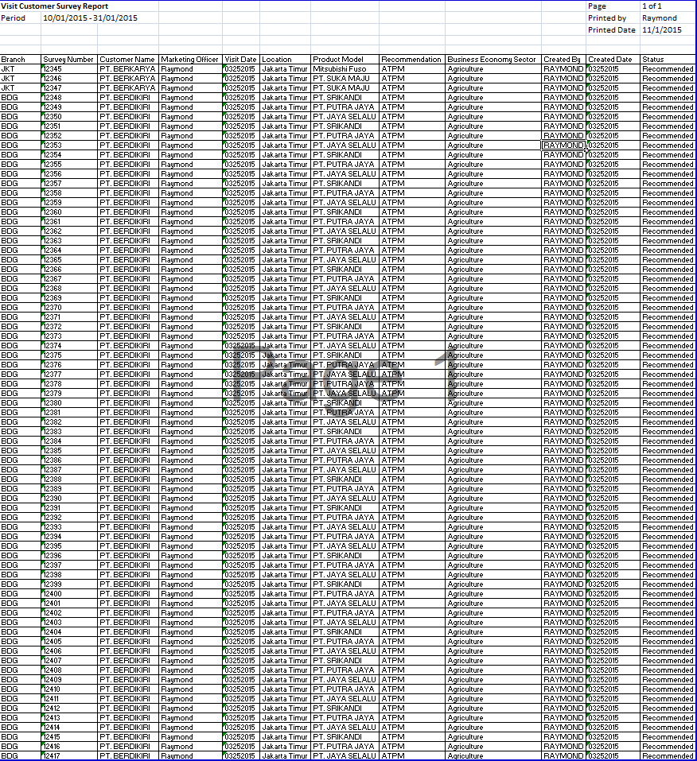

17

16

15

14

13

12

11

10

9

8

7

6

5

4

3

2

1

**EMAIL.AB.1.1 Visit Customer Survey Email**

|  |  |  |  |  |
| --- | --- | --- | --- | --- |
| *No.* | *Content* | *Description* | *Source* | *Remarks* |
| 1 | From | From | Employee.Email | *NB: Employee related to the User Login* |
| 2 | To | To |  | *NB: Refer to* ***Functional Specification FC.C.1 System Setting*** |
| 3 | Cc | Cc |  | *NB: Refer to* ***Functional Specification FC.C.1 System Setting*** |
| 4 | Subject | Subject |  | *Visit Report “Customer Name”* |
| 5 | Attachment | Attachment |  | *Visit Report “Customer Name”.pdf* |
| 6 | Body Email | Body Email |  |  |
| 7 | Customer Name | Customer Name | Customer.CustomerName |  |
| 8 | Visit Date | Visit Date | Tb\_MKT\_VisitCustSurvey.VisitDate |  |

**EMAIL.AB.1.1 Visit Customer Survey Email**

1



8

7

2

6

5

4

3

* 1. Data Structure

1. **Tb\_MKT\_VisitCustSurvey**

|  |  |  |  |  |  |  |
| --- | --- | --- | --- | --- | --- | --- |
| *Field Name* | *Data Type* | *Length* | *Source* | *Remarks* | *Nullable* | *Mandatory* |
| *Primary Key Visit Customer Survey* | *Int* | *N/A* | Tb\_MKT\_VisitCustSurvey. IdTb\_MKT\_VisitCustSurvey | ***Primary Key*** | No | Yes |
| Survey Number | *Varchar* | *20* | Tb\_MKT\_VisitCustSurvey.SurveyNo | ***Unique Key*** | No | Yes |
| Employee Name | *Varchar* | *50* | Tb\_OPL\_Employee.EmployeeName | *Where Tb\_OPL\_Employee.IdEmployee = Tb\_MKT\_VisitCustSurvey.IdEmployee* | No | Yes |
| Recommendation | *Varchar* | *20* | OptionItemsValue. IdOptionItemValue | *WHERE Tb\_MKT\_VisitCustSurvey.IdTb\_MKT\_VisitCustSurvey = Tb\_MKT\_VisitUsagePurposeList. IdTb\_MKT\_VisitCustSurvey*  *AND*  *Tb\_MKT\_VisitUsagePurposeList.IdOptionItemValue = OptionItemValue. IdOptionItemValue* | Yes | No |
| Recommendation (other) | *Varchar* | *20* | Tb\_MKT\_VisitCustSurvey.RecommendationOthers |  | Yes | No |
| Recommendation Name | *Varchar* | *50* | Tb\_MKT\_VisitCustSurvey.RecomName |  | Yes | No |
| Time | *Time* | *N/A* | Tb\_MKT\_VisitCustSurvey.Time | *Format “hh:mm”* | No | Yes |
| Visit Date | *Date* | *N/A* | Tb\_MKT\_VisitCustSurvey.VisitDate | *Format “mmddyyyy”* | No | Yes |
| Visit Location | *Varchar* | *50* | Tb\_MKT\_VisitCustSurvey.VisitLoc |  | No | Yes |
| Category | *Int* | *N/A* | OptionItemsValue. IdOptionItemValue | *Where Tb\_MKT\_VisitCustSurvey.IdOptionItems = OptionItems.IdOptionItems*  *AND*  *OptionItems.IdOptionItemValue = OptionItemsValue. IdOptionItemValue* | No | Yes |
| Customer Name | *Varchar* | *50* | Customer.CustomerName | *Where Tb\_MKT\_VisitCustSurvey.IdCustomer = Customer.IdCustomer* | No | Yes |
| Website | *Varchar* | *30* | Tb\_MKT\_VisitCustSurvey.Website |  | Yes | No |
| Address | *Varchar* | *100* | Customer.Address | *Where Tb\_MKT\_VisitCustSurvey.IdCustomer = Customer.IdCustomer* | No | Yes |
| Business Economy Sector | *Varchar* | *30* | Customer.BusinessEconomySector | *Where Tb\_MKT\_VisitCustSurvey.IdCustomer = Customer.IdCustomer* | Yes | No |
| Number of Branch | *Int* | *N/A* | Customer.BranchNumber | *Where Tb\_MKT\_VisitCustSurvey.IdCustomer = Customer.IdCustomer* | Yes | No |
| Contact Person | *Varchar* | *50* | Tb\_MKT\_VisitCustSurvey.ContactPerson |  | No | Yes |
| Decision Maker | *Varchar* | *50* | Tb\_MKT\_VisitCustSurvey.DecisionMaker |  | No | Yes |
| Position | *Varchar* | *20* | Tb\_MKT\_VisitCustSurvey.Position |  | No | Yes |
| Telephone Number | *Varchar* | *20* | Tb\_MKT\_VisitCustSurvey.TelephoneNumber |  | No | Yes |
| Product Registration Code | *Varchar* | *20* | Product.ProductCode | *WHERE Tb\_MKT\_VisitCustSurvey.IdProduct = Product.IdProduct* | No | Yes |
| Product Brand Code | *Varchar* | *20* | Product.BrandCode | *WHERE Tb\_MKT\_VisitCustSurvey.IdProduct = Product.IdProduct* | No | Yes |
| Product Brand Name | *Varchar* | *20* | Product.BrandName | *WHERE Tb\_MKT\_VisitCustSurvey.IdProduct = Product.IdProduct* | No | Yes |
| Product Model Code | *Varchar* | *20* | Product.ModelCode | *WHERE Tb\_MKT\_VisitCustSurvey.IdProduct = Product.IdProduct* | No | Yes |
| Product Model Name | *Varchar* | *20* | Product.ModelName | *WHERE Tb\_MKT\_VisitCustSurvey.IdProduct = Product.IdProduct* | No | Yes |
| Product Model Type | *Varchar* | *20* | Product.ModelType | *WHERE Tb\_MKT\_VisitCustSurvey.IdProduct = Product.IdProduct* | No | Yes |
| Product Model Year | *Varchar* | *20* | Product.ModelYear | *WHERE Tb\_MKT\_VisitCustSurvey.IdProduct = Product.IdProduct* | No | Yes |
| Product Type | *Varchar* | *20* | ProductType.ProductType | *WHERE Tb\_MKT\_VisitCustSurvey.IdProductType = ProductType.IdProductType* | No | Yes |
| Product Category | *Varchar* | *20* | ProductCategory.ProductCategory | *WHERE Tb\_MKT\_VisitCustSurvey.IdProduct = Product.IdProduct*  *AND*  *Product.IdProductCategory = ProductCategory.IdProductCategory* | No | Yes |
| Lease Period | *Int* | *N/A* | Tb\_MKT\_VisitCustSurvey.LeasePeriod |  | Yes | No |
| Quantity Request | *Int* | *N/A* | Tb\_MKT\_VisitCustSurvey.QuantityRequest |  | Yes | No |
| OPL Reason | *Int* | *N/A* | OptionItemsValue. IdOptionItemValue | *WHERE Tb\_MKT\_VisitCustSurvey.IdTb\_MKT\_VisitCustSurvey = Tb\_MKT\_VisitOPLReasonList. IdTb\_MKT\_VisitCustSurvey*  *AND*  *Tb\_MKT\_VisitOPLReasonList.IdOptionItemValue = OptionItemValue. IdOptionItemValue* | Yes | No |
| Usage Purpose | *Int* | *N/A* | OptionItemsValue. IdOptionItemValue | *WHERE Tb\_MKT\_VisitCustSurvey.IdTb\_MKT\_VisitCustSurvey = Tb\_MKT\_VisitUsagePurposeList. IdTb\_MKT\_VisitCustSurvey*  *AND*  *Tb\_MKT\_VisitUsagePurposeList.IdOptionItemValue = OptionItemValue. IdOptionItemValue* | Yes | No |
| Usage Purpose (other) | *Varchar* | *50* | Tb\_MKT\_VisitCustSurvey.UsagePurposeOthers |  | Yes | No |
| Usage | *Int* | *N/A* | OptionItemsValue. IdOptionItemValue | *Where Tb\_MKT\_VisitCustSurvey.IdOptionItems = OptionItems.IdOptionItems*  *AND*  *OptionItems.IdOptionItemValue = OptionItemsValue. IdOptionItemValue* | Yes | No |
| Usage Address | *Varchar* | *100* | Tb\_MKT\_VisitCustSurvey.UsageAddress |  | Yes | No |
| Monthly Mileage | *Int* | *N/A* | Tb\_MKT\_VisitCustSurvey.MonthlyMileage |  | Yes | No |
| Maximum Mileage (km/month) | *Int* | *N/A* | Tb\_MKT\_VisitCustSurvey.MaxiMileage |  | Yes | No |
| Minimum Mileage (km/month) | *Int* | *N/A* | Tb\_MKT\_VisitCustSurvey.MinMileage |  | Yes | No |
| Average Mileage (km/month) | *Int* | *N/A* | Tb\_MKT\_VisitCustSurvey.AverageMileage |  | Yes | No |
| Hours Spent Daily Usage | *Int* | *N/A* | Tb\_MKT\_VisitCustSurvey.HoursSpentDailyUsage |  | Yes | No |
| Days Spent Monthly Usage | *Int* | *N/A* | Tb\_MKT\_VisitCustSurvey.DaysSpentMonthlyUsage |  | Yes | No |
| Replacement Car | *Bit* | *N/A* | Tb\_MKT\_VisitCustSurvey.ReplacementCar |  | Yes | No |
| Maintenance Type | *Int* | *N/A* | OptionItemsValue. IdOptionItemValue | *WHERE Tb\_MKT\_VisitCustSurvey.IdTb\_MKT\_VisitCustSurvey = Tb\_MKT\_VisitMaintenanceTypeList. IdTb\_MKT\_VisitCustSurvey*  *AND*  *Tb\_MKT\_VisitMaintenanceTypeList.IdOptionItemValue = OptionItemValue. IdOptionItemValue* | Yes | No |
| At the end of period | *Int* | *N/A* | OptionItemsValue. IdOptionItemValue | *Where Tb\_MKT\_VisitCustSurvey.IdOptionItems = OptionItems.IdOptionItems*  *AND*  *OptionItems.IdOptionItemValue = OptionItemsValue. IdOptionItemValue* | Yes | No |
| Residual Value | *Int* | *N/A* | Tb\_MKT\_VisitCustSurvey.ResidualValue |  | Yes | No |
| For (month(s)) | *Int* | *N/A* | Tb\_MKT\_VisitCustSurvey.ExtendedMonths |  | Yes | No |
| Maximum Breakdown | *Int* | *N/A* | Tb\_MKT\_VisitCustSurvey.MaximumBreakdown |  | Yes | No |
| Maximum Credit Line | *Int* | *N/A* | Customer.MaxCreditLine | *Where Tb\_MKT\_VisitCustSurvey.IdCustomer = Customer.IdCustomer* | Yes | No |
| Total Credit Balance Group | *Int* | *N/A* | Customer.TCBalanceGroup | *Where Tb\_MKT\_VisitCustSurvey.IdCustomer = Customer.IdCustomer* | Yes | No |
| Overdue Amount | *Int* | *N/A* | Customer.OverdueAmount | *Where Tb\_MKT\_VisitCustSurvey.IdCustomer = Customer.IdCustomer* | Yes | No |
| Total Credit Balance Single | *Int* | *N/A* | Customer.TCBalanceSingle | *Where Tb\_MKT\_VisitCustSurvey.IdCustomer = Customer.IdCustomer* | Yes | No |
| Overdue Number | *Int* | *N/A* | Customer.OverdueNumber | *Where Tb\_MKT\_VisitCustSurvey.IdCustomer = Customer.IdCustomer* | Yes | No |
| Customer Vehicle Unit | *Int* | *N/A* | Customer.CustomerVehicleUnit | *Where Tb\_MKT\_VisitCustSurvey.IdCustomer = Customer.IdCustomer* | Yes | No |
| Customer Forklift Unit | *Int* | *N/A* | Customer.CustomerForkliftUnit | *Where Tb\_MKT\_VisitCustSurvey.IdCustomer = Customer.IdCustomer* | Yes | No |
| Customer HE Unit | *Int* | *N/A* | Customer.CustomerHEUnit | *Where Tb\_MKT\_VisitCustSurvey.IdCustomer = Customer.IdCustomer* | Yes | No |
| DSF Vehicle Unit | *Int* | *N/A* | Customer.DSFVehicleUnit | *Where Tb\_MKT\_VisitCustSurvey.IdCustomer = Customer.IdCustomer* | Yes | No |
| DSF Forklift Unit | *Int* | *N/A* | Customer.DSFForkliftUnit | *Where Tb\_MKT\_VisitCustSurvey.IdCustomer = Customer.IdCustomer* | Yes | No |
| DSF HE Unit | *Int* | *N/A* | Customer.DSFHEUnit | *Where Tb\_MKT\_VisitCustSurvey.IdCustomer = Customer.IdCustomer* | Yes | No |
| Potential Vehicle Unit | *Int* | *N/A* | Customer.PotentialVehicleUnit | *Where Tb\_MKT\_VisitCustSurvey.IdCustomer = Customer.IdCustomer* | Yes | No |
| Potential Forklift Unit | *Int* | *N/A* | Customer.PotentialForkliftUnit | *Where Tb\_MKT\_VisitCustSurvey.IdCustomer = Customer.IdCustomer* | Yes | No |
| Potential HE Unit | *Int* | *N/A* | Customer.PotentialHEUnit | *Where Tb\_MKT\_VisitCustSurvey.IdCustomer = Customer.IdCustomer* | Yes | No |
| Information Acquisition Date Vehicle Unit | *Date* | *N/A* | Customer.IADVehicleUnit | *Where Tb\_MKT\_VisitCustSurvey.IdCustomer = Customer.IdCustomer* | Yes | No |
| Information Acquisition Date Forklift Unit | *Date* | *N/A* | Customer.IADForkliftUnit | *Where Tb\_MKT\_VisitCustSurvey.IdCustomer = Customer.IdCustomer* | Yes | No |
| Information Acquisition Date HE Unit | *Date* | *N/A* | Customer.IADHEUnit | *Where Tb\_MKT\_VisitCustSurvey.IdCustomer = Customer.IdCustomer* | Yes | No |
| LCV NonMaintenance | *Int* | *N/A* | Customer.LCVNonMaintenance | *Where Tb\_MKT\_VisitCustSurvey.IdCustomer = Customer.IdCustomer* | Yes | No |
| CV NonMaintenance | *Int* | *N/A* | Customer.CVNonMaintenance | *Where Tb\_MKT\_VisitCustSurvey.IdCustomer = Customer.IdCustomer* | Yes | No |
| PC NonMaintenance | *Int* | *N/A* | Customer.PCNonMaintenance | *Where Tb\_MKT\_VisitCustSurvey.IdCustomer = Customer.IdCustomer* | Yes | No |
| Forklift NonMaintenance | *Int* | *N/A* | Customer.ForkliftNonMaintenance | *Where Tb\_MKT\_VisitCustSurvey.IdCustomer = Customer.IdCustomer* | Yes | No |
| HE NonMaintenance | *Int* | *N/A* | Customer.HENonMaintenance | *Where Tb\_MKT\_VisitCustSurvey.IdCustomer = Customer.IdCustomer* | Yes | No |
| LCV Maintenance | *Int* | *N/A* | Customer.LCVMaintenance | *Where Tb\_MKT\_VisitCustSurvey.IdCustomer = Customer.IdCustomer* | Yes | No |
| CV Maintenance | *Int* | *N/A* | Customer.CVMaintenance | *Where Tb\_MKT\_VisitCustSurvey.IdCustomer = Customer.IdCustomer* | Yes | No |
| PC Maintenance | *Int* | *N/A* | Customer.PCMaintenance | *Where Tb\_MKT\_VisitCustSurvey.IdCustomer = Customer.IdCustomer* | Yes | No |
| Forklift Maintenance | *Int* | *N/A* | Customer.ForkliftMaintenance | *Where Tb\_MKT\_VisitCustSurvey.IdCustomer = Customer.IdCustomer* | Yes | No |
| HE Maintenance | *Int* | *N/A* | Customer.HEMaintenance | *Where Tb\_MKT\_VisitCustSurvey.IdCustomer = Customer.IdCustomer* | Yes | No |
| LCV CSD | *Int* | *N/A* | Customer.LCVCSD | *Where Tb\_MKT\_VisitCustSurvey.IdCustomer = Customer.IdCustomer* | Yes | No |
| CV CSD | *Int* | *N/A* | Customer.CVCSD | *Where Tb\_MKT\_VisitCustSurvey.IdCustomer = Customer.IdCustomer* | Yes | No |
| PC CSD | *Int* | *N/A* | Customer.PCCSD | *Where Tb\_MKT\_VisitCustSurvey.IdCustomer = Customer.IdCustomer* | Yes | No |
| Forklift CSD | *Int* | *N/A* | Customer.ForkliftCSD | *Where Tb\_MKT\_VisitCustSurvey.IdCustomer = Customer.IdCustomer* | Yes | No |
| HE CSD | *Int* | *N/A* | Customer.HECSD | *Where Tb\_MKT\_VisitCustSurvey.IdCustomer = Customer.IdCustomer* | Yes | No |
| LCV Finance Lease | *Int* | *N/A* | Customer.LCVFinanceLease | *Where Tb\_MKT\_VisitCustSurvey.IdCustomer = Customer.IdCustomer* | Yes | No |
| CV Finance Lease | *Int* | *N/A* | Customer.CVFinanceLease | *Where Tb\_MKT\_VisitCustSurvey.IdCustomer = Customer.IdCustomer* | Yes | No |
| PC Finance Lease | *Int* | *N/A* | Customer.PCFinanceLease | *Where Tb\_MKT\_VisitCustSurvey.IdCustomer = Customer.IdCustomer* | Yes | No |
| Forklift Finance Lease | *Int* | *N/A* | Customer.ForkliftFinanceLease | *Where Tb\_MKT\_VisitCustSurvey.IdCustomer = Customer.IdCustomer* | Yes | No |
| HE Finance Lease | *Int* | *N/A* | Customer.HEFinanceLease | *Where Tb\_MKT\_VisitCustSurvey.IdCustomer = Customer.IdCustomer* | Yes | No |
| Vehicle Commercial Type (%) | *Decimal* | *18,3* | Tb\_MKT\_VisitCustSurvey.VehicleCommercialType |  | Yes | No |
| Passenger Vehicle Type (%) | *Decimal* | *18,3* | Tb\_MKT\_VisitCustSurvey.VehiclePassengerType |  | Yes | No |
| Possession Method Cash (%) | *Decimal* | *18,3* | Tb\_MKT\_VisitCustSurvey.PossessionMethodCash |  | Yes | No |
| Possession Method Bank (%) | *Decimal* | *18,3* | Tb\_MKT\_VisitCustSurvey.PossessionMethodBank |  | Yes | No |
| Possession Method Lease (%) | *Decimal* | *18,3* | Tb\_MKT\_VisitCustSurvey.PossessionMethodLease |  | Yes | No |
| Possession Method Rent (%) | *Decimal* | *18,3* | Tb\_MKT\_VisitCustSurvey.PossessionMethodRent |  | Yes | No |
| Competitor Company | *Varchar* | *50* | Tb\_MKT\_VisitCustSurvey. CompetCompany |  | Yes | No |
| Vehicle Maintenance | *Varchar* | *50* | OptionItemsValue. IdOptionItemValue | *Where Tb\_MKT\_VisitCustSurvey.IdOptionItems = OptionItems.IdOptionItems*  *AND*  *OptionItems.IdOptionItemValue = OptionItemsValue. IdOptionItemValue* | Yes | No |
| Number of Mechanics | *Int* | *N/A* | Tb\_MKT\_VisitCustSurvey. NumMechanics |  | Yes | No |
| Frequent Maintenance | *Int* | *N/A* | OptionItemsValue. IdOptionItemValue | *WHERE Tb\_MKT\_VisitCustSurvey.IdTb\_MKT\_VisitCustSurvey = Tb\_MKT\_VisitFreqMaintenanceList. IdTb\_MKT\_VisitCustSurvey*  *AND*  *Tb\_MKT\_VisitFreqMaintenanceList.IdOptionItemValue = OptionItemValue. IdOptionItemValue* | Yes | No |
| Frequent Maintenance (Other) | *Int* | *N/A* | Tb\_MKT\_VisitCustSurvey.FreqMaintenanceOthers |  | Yes | No |
| Disposal Method | *Varchar* | *50* | Tb\_MKT\_VisitCustSurvey. DisposMethod |  | Yes | No |
| Vehicle Supervision | *Varchar* | *50* | OptionItemsValue. IdOptionItemValue | *WHERE Tb\_MKT\_VisitCustSurvey.IdTb\_MKT\_VisitCustSurvey = Tb\_MKT\_VisitVehicleSupervisionList. IdTb\_MKT\_VisitCustSurvey*  *AND*  *Tb\_MKT\_VisitVehicleSupervisionList.IdOptionItemValue = OptionItemValue. IdOptionItemValue* | Yes | No |
| Number of Branch Office | *Int* | *N/A* | Tb\_MKT\_VisitCustSurvey. NumBranchOffice |  | Yes | No |
| Number of Workshops | *Varchar* | *50* | Tb\_MKT\_VisitCustSurvey. NumWorkshops |  | Yes | No |
| Maintenance Cost | *Decimal* | *18,3* | Tb\_MKT\_VisitCustSurvey. MaintenanceCost |  | Yes | No |
| Disposal Method (Other) | *Varchar* | *50* | Tb\_MKT\_VisitCustSurvey. DisposMethodOthers |  | Yes | No |
| Recommended | *Bit* | *N/A* | Tb\_MKT\_VisitCustSurvey.Recommended |  | No | Yes |
| Extra Notes | *Varchar* | *500* | Tb\_MKT\_VisitCustSurvey.ExtraNotes |  | No | Yes |
| Revision User Name | *Varchar* | *50* | Tb\_MKT\_VisitCustSurvey\_History.CreatedBy |  | No | No |
| Revision Date | *Datetime* | *N/A* | Tb\_MKT\_VisitCustSurvey\_History.CreatedDate | *Format “mmddyyyy hh:mm”* | No | No |
| Revision Status | *Varchar* | *50* | Tb\_MKT\_VisitCustSurvey\_History.Action |  | No | No |
| Created By | *Varchar* | *20* | Tb\_MKT\_VisitCustSurvey. CreatedBy |  | No | Yes |
| Created Date | *Datetime* | *N/A* | Tb\_MKT\_VisitCustSurvey. CreatedDate | *Format “mmddyyyy hh:mm:ss”* | No | Yes |
| Last Modified By | *Varchar* | *20* | Tb\_MKT\_VisitCustSurvey. LastModifiedBy |  | No | Yes |
| Last Modified Date | *Datetime* | *N/A* | Tb\_MKT\_VisitCustSurvey.LastModifiedDate | *Format “mmddyyyy hh:mm:ss”* | No | Yes |
| Status | *Int* | *N/A* | Tb\_MKT\_VisitCustSurvey. Tb\_OPL\_Status |  | No | Yes |
| Deletion Status | *Bit* | *N/A* | Tb\_MKT\_VisitCustSurvey. IsDelete |  | No | Yes |

**ERD Structure**

****

**APPENDIX**

Configuration Access for Visit Customer Survey functions:

|  |  |  |  |  |  |  |  |
| --- | --- | --- | --- | --- | --- | --- | --- |
| **User** | **Branch** | **Functions** | | | | | |
| **Display List** | **Create** | **Edit** | **View** | **Print Form** | **Print Report** |
| Marketing Officer | One | V | V | V | V | V | V |
| Area |  |  |  |  |  |  |
| All |  |  |  |  |  |  |
| Head of Branch | One | V |  |  | V | V | V |
| Area |  |  |  |  |  |  |
| All |  |  |  |  |  |  |
| Head of Department | One |  |  |  |  |  |  |
| Area |  |  |  |  |  |  |
| All | V |  |  | V | V | V |
| Regional Manager | One |  |  |  |  |  |  |
| Area | V |  |  | V | V | V |
| All |  |  |  |  |  |  |
| Advisor | One |  |  |  |  |  |  |
| Area |  |  |  |  |  |  |
| All | V |  |  | V | V | V |
| Director | One |  |  |  |  |  |  |
| Area |  |  |  |  |  |  |
| All | V |  |  | V | V | V |
| President Director | One |  |  |  |  |  |  |
| Area |  |  |  |  |  |  |
| All | V |  |  | V | V | V |
| Shareholder's Meeting | One |  |  |  |  |  |  |
| Area |  |  |  |  |  |  |
| All | V |  |  | V | V | V |
|  |  |  |  |  |  |  |  |
| **Legend:** |  |  |  |  |  |  |  |
| V = Have the access |  |  |  |  |  |  |  |